

ECOLE NATIONALE SUPERIEURE

POLYTECHNIQUE DE YAOUNDE



**TRAVAUX PRATIQUES DES SYSTEMES DES TELECOMMUNICATIONS MOBILES**

**THEME**

**:**

Travaux pratiques avec Packet Tracer pour la mise en œuvre de l’IoT

**PROFESSEUR :**

**Pr**

**EMMANUEL TONYE**

**ETUDIANT**

**:**

**ADAMOU**

**MASSAMA**

**CLASSE**

**:**

**4**

**-**

**GTEL**

**MARICULE**

**:**

**16P136**

**ETUDIANT**

**:**

**EKASSI ELOUNDOU JEAN ANICET**

**CLASSE**

**:**

**4**

**-**

**GTEL**

**MARICULE**

**:**

**18**

**P**

**277**

**ETUDIANT**

**KETCHEMEN**

**:**

**TCHOUNDJEUH ARMEL ROSTAND**

**CLASS**

**E**

**:**

**4**

**-**

**GTEL**

**MARICULE**

**:**

**17P212**

**ETUDIANT**

**:**

**NKUH RHOLY NKONGNYUH**

**CLASSE**

**:**

**4**

**-**

**GTEL**

**MARICULE :**

**16P162**

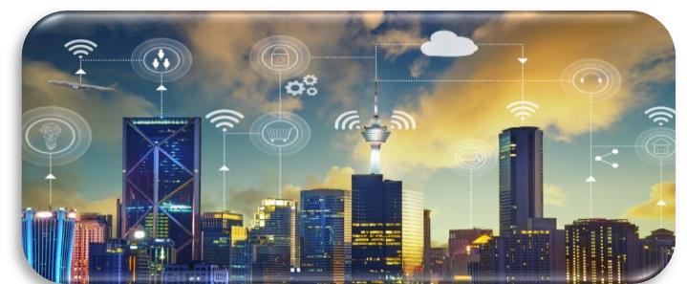

**PRACTICALS ON IOT SOLUTIONS ON CISCO PACKET TRACER**

**INTRODUCTION**

With a fast increase and rise in technology, there has been a boom in what we could call “smart objects”. That has led to the creation of partially intelligent objects. The main application is in smart phones. Phones with an operating system, a memory, a CPU. They can process information faster than the previous type of phones and the greatest thing is that it evolves too.

With that in mind, the demand in smart objects increased and with the polishing of the internet it literally was possible. But how??

The internet being the largest network ever, the idea to render things smarter was to render it a little intelligent using the internet. But using the internet would not be sufficient indeed. There was the need of developing objects that would actively and rapidly communicate through the internet, hence rendering other institutes smarter.

There came the **IoT technology.** Literally standing for the **Internet of Things**. Objects who can actively communicate through the internet and also communicate locally. To put such a feat in place, many other concepts were attached to it such as **cloud computing, mobile networking.** In this era then and the coming of the 5G, the IoT technology has totally been mastered and launched and has become a rush by various telecom giants who want to provide IoT solutions.

In this little piece of art, we shall be discussing briefly but yet deeply on the concept of Internet of Things. We shall also add to that the notion of cloud computing, and fog computing, programming microcomputers using several advanced programming languages such as C, python, java script etc. Our setting shall be done based on 10 extensive practicals on IoT provided by the leading telecom equipment solution provider in the matter, **CISCO**. We shall flow from the basic control of office equipment, to smart homes, smart industries, smart cities and if possible smart grids with the sole idea in the back of our mind, interconnecting objects locally and also widely in order to render them smarter. The practicals shall be done on CISCO packet tracer, a powerful simulator that permits real life simulations of networking problems and in our case IoT challenges.

**PRACTICAL 1: CREATING AN IOT TOPOLOGY**

The beginning of every practical is to get acquainted to the equipment being used. That is actually the goal to this experiment. In the lines below, we shall be coursing through elementary things that have to be done before being able to effectively work with IoT equipment.

**AIM:** Creating an IoT topology and understanding how each equipment functions.

**DIAGRAM:**

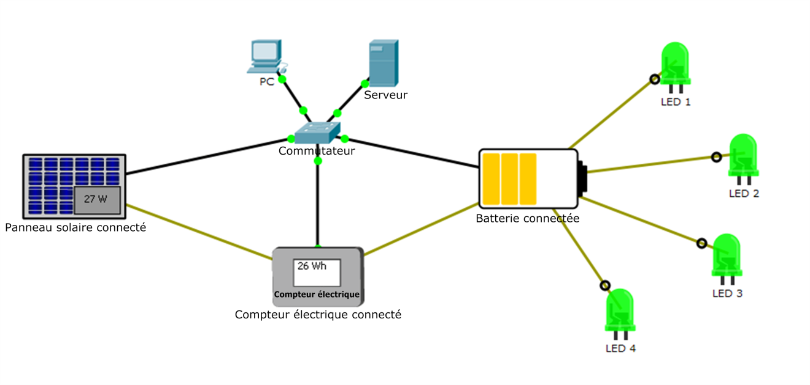

**Main Idea:** The idea behind it is to be able to monitor the IoT equipment in the network above from the end station (PC). The switch will put them in the same VLAN and their respective data after configuration will be stored on the server (IoT server). The end station will access the server and hence be able to navigate through the data of the IoT equipment and actively monitor their states in the network.

Well, that’s the Idea. But how did we do that?? The answer is in the lines below.

**PROCEDURE/SIMULATION:**

**Step 1:** The equipment was mounted as shown in the image above and also with respect to the practical guide that was given.

**Step 2:** We configured and activated the following services; **DHCP** and **IoT**. This services makes the server assign Ip addresses to the devices directly or indirectly connected to it (DHCP) with respect to the configurations made on the server, and it also permits the storage of the data transmitted by the IoT devices (IoT service).

So, we started by configuring statically configuring the server Ip address. After that, we activated the DHCP service precising the Ip address interval used and we finally went forth to activate the IoT service as shown in the images below.

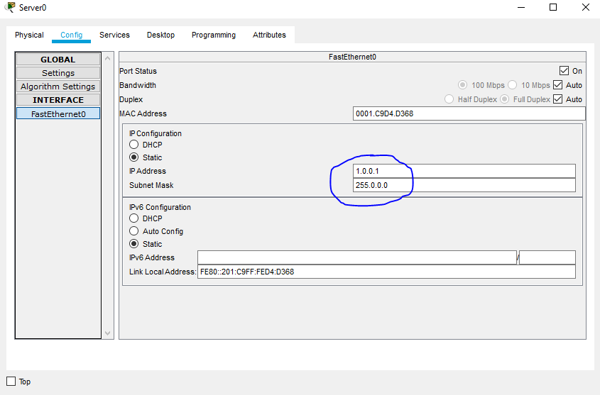

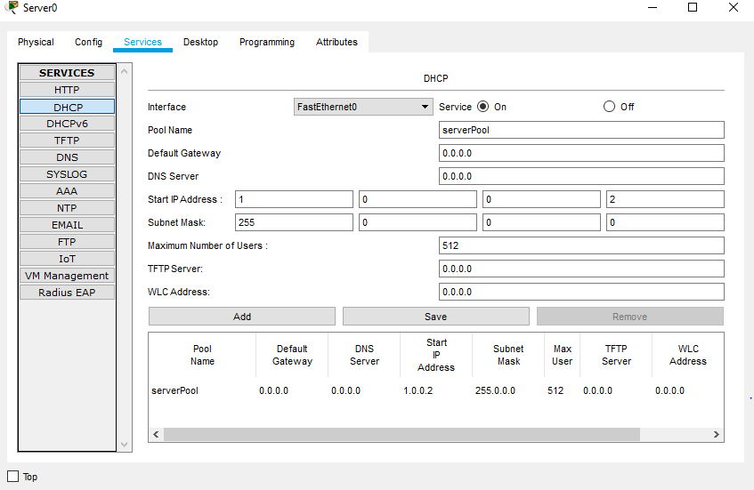

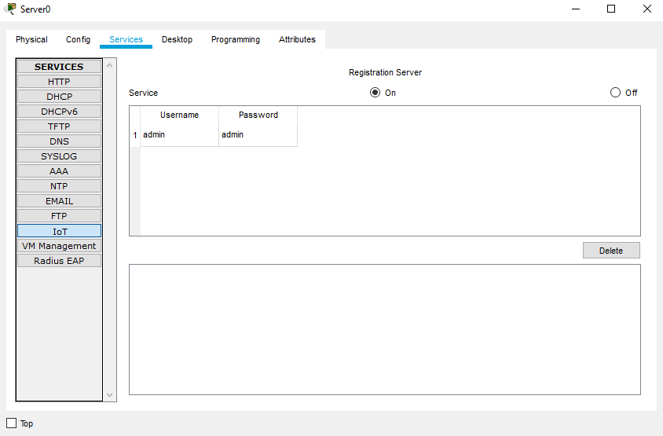

**Step 3:** We proceeded to configure the end station (PC) to connect to the server. To achieve that, we did the following;

* We clicked on the PC, accessed the **desktop** then **web browser**.
* Typed the following server Ip address **1.0.0.1** and pressed enter.
* Then we filled the following information;

Username: admin

Password : admin

We got the following results;

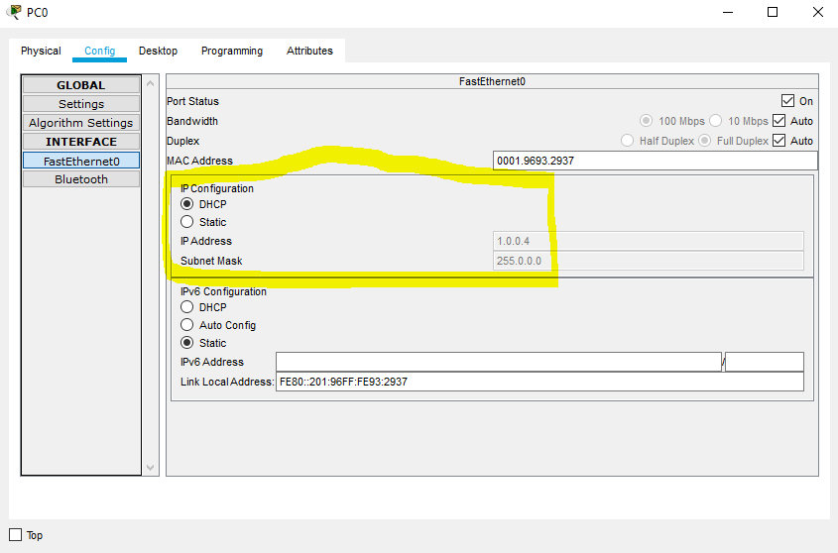

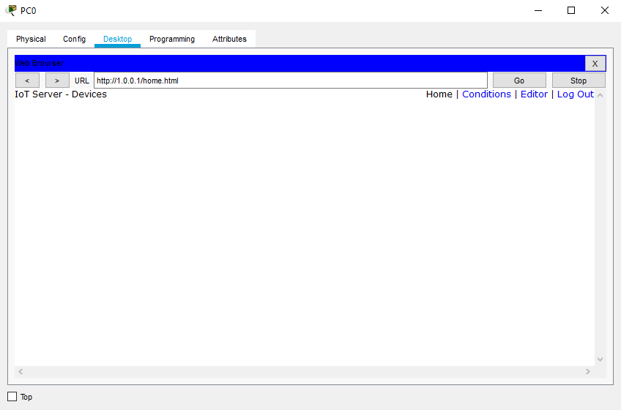

And as someone would remark it, there are no IoT devices. This is due to the fact that the IoT devices have not been registered yet.

**Step 4:** We registered each IoT device on the server.

To do so, we proceeded as follows;

* We activated the DHCP service on each IoT device, in other to dynamically receive Ip addresses from the server.
* On each device, we accessed the **config** window, then **settings**, and under **IoT server**, we chose **remote server** and filled in the following information; server address: 1.0.0.1, Username: admin and Password: admin
* Then we clicked on **connect**, as shown in the images below

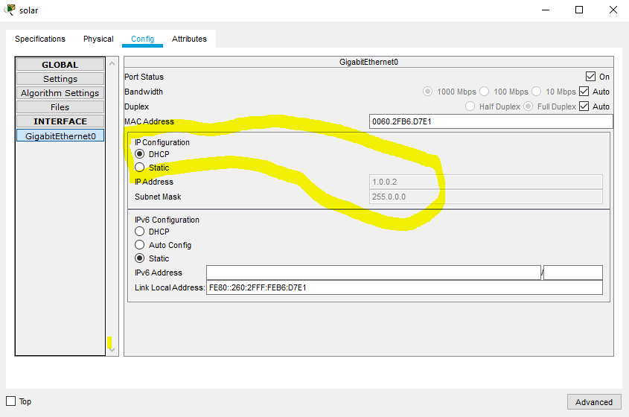

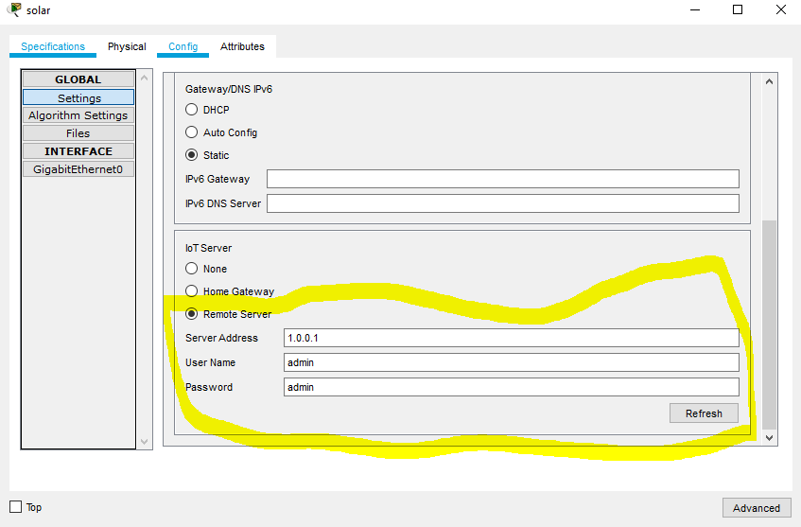

**NB: The steps above were done for all the IoT devices**

After doing that, we repeated back **step 3** and got the following results;

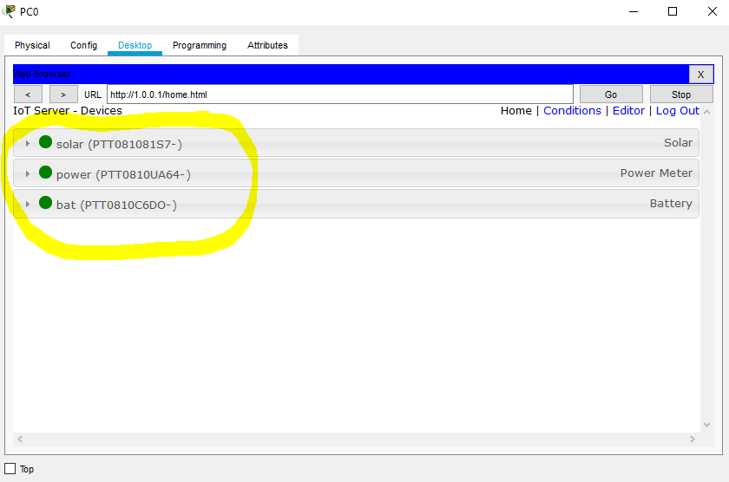

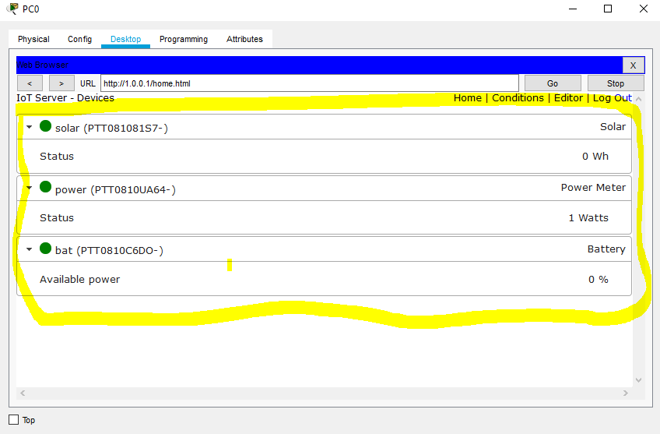

**PRACTICAL 2: SIMULATION OF IOT DEVICES**

**Topology**

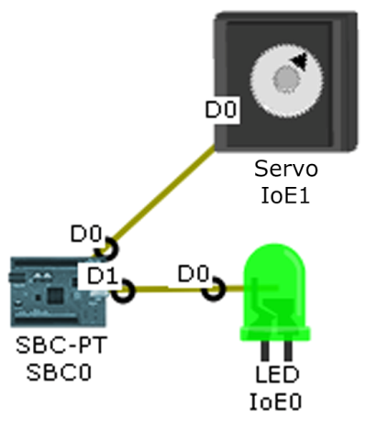

**Main Idea**

In this case, we have a programmable logic controller (SBC), a servo motor and a LED. The Idea here is to command the LED and the servo motor via the programmable logic controller.

**Procedure**

**Step 1:** On packet tracer, we realized the topology above by intrinsically following the guide provided.

**Step 2:** Since the SBC came with a default program, we decided to execute the default program. We did that as follows;

* We double clicked on the **SBC** and accessed the **programming** window.
* We double clicked on **Blink (python)** found on the left side panel, in order to open it.
* We double clicked on **main.py** in order to see the code properly.
* We finally clicked on **RUN** in order to launch the program.

This was done as shown in the image below;

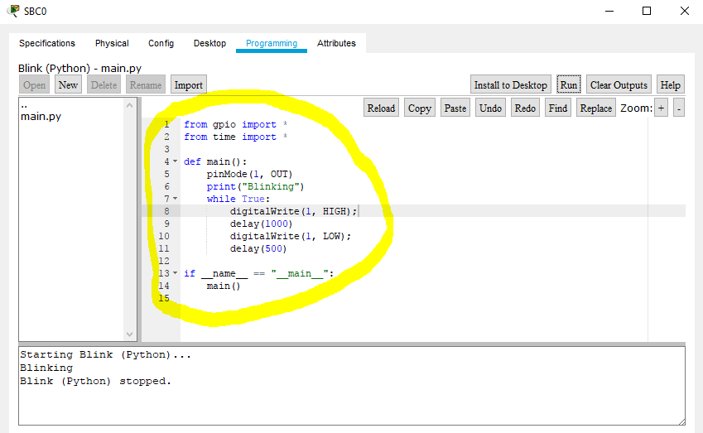

**Remark:** After launching the default program, one noticed that only the LED was blinking. The servo motor remained static. Hence for the SBC controller to command both the rotation of the servo motor and the LED blinking, one modified the default program.

**Step 3:** We modified the default program. We did the following;

**a. customWrite(0,127); just after digitalWrite(1, HIGH);**

**b. customWrite(0, -127); just after digitalWrite(1, LOW);**

**c. Then we launched the modified program**

**Remark:** Observing the code, one notices that on custom write, there are the numbers 0 and 127, then 0 and -127. This gives us the maximum rotatory angle swept by our servo motor. So, one can change the 127 to any number that one wants. Hence, what we remarked was this;

* When the motor was at its maximum rotatory angle (127 degrees) the LED came on and the reverse was also true.

**Step 4:** We further modified the program by doing the following;

**a. customWrite(0,-127); just after digitalWrite(1, HIGH);**

**b. customWrite(0, 127); just after digitalWrite(1, LOW);**

**c. Then we launched the modified program**

**Remark:** After modifying the program once more, this time reversing the angles at HIGH and at LOW, we noticed that;

* This time, when the motor was at its maximum rotatory angle, the LED was off and the reverse was also true.

**PRACTICAL 3: SENSORS AND PT-MICROCONTROLLER**

**Topology**

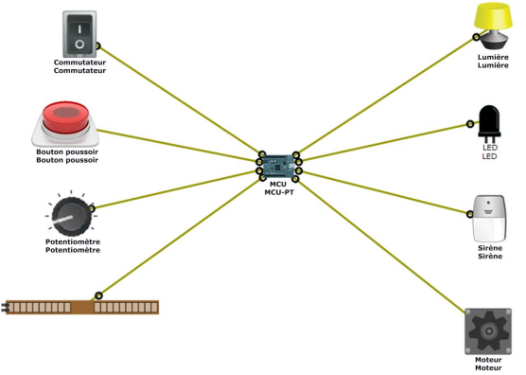

**Main Idea:** Here we want to use the switches and potentiometers to give a specific command or action to some devices through a programmable microcontroller (In our case a PT-MCU).

**Procedure:**

**Step 1:** The topology was realised as shown on the figure above, following intrinsically the guide provided.

**Step 2:** We went further to program the MCU controller.

In packet tracer, each of the controllers come with a default code already in build in them. When we ran that code, nothing happened. So, we had to write a code that will take in to consideration the task to achieve.

The code that gave a specific command to the outputs with respect to the input twitch was written in a Java script language. The code was as follows;

**function setup() {**

**pinMode(0, INPUT);**

**pinMode(1, INPUT);**

**pinMode(A0, INPUT);**

**pinMode(A1, INPUT);**

**pinMode(2, OUTPUT);**

**pinMode(3, OUTPUT);**

**pinMode(4, OUTPUT);**

**pinMode(5, OUTPUT);**

**Serial.println("Blinking");**

**}**

**function loop() {**

**if (digitalRead(0)== HIGH)**

**customWrite(2, 2);**

**else**

**customWrite(2, 0);**

**if (digitalRead(1)== HIGH)**

**digitalWrite(3, HIGH);**

**else**

**digitalWrite(3, LOW);**

**if (analogRead(A0)>= 125)**

**customWrite(4, 1);**

**else**

**customWrite(4, 0);**

**if (analogRead(A1) > 0)**

**analogWrite(5, analogRead(A1))**

**else**

**analogWrite(5, 0)**

**}**

**Step 3:** We then simulated the practical.

With that code, we were able to fully command our outputs with respect to the inputs.

**NB:** This was fully visualized when practicing, but for a better view we attached some videos to this report to make it highly interactive and expendable.

**PRACTICAL 4: PROGRAMMING A MICROCONTROLLER USING PYTHON**

**Topology**

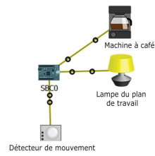

**Main Idea:** The Idea here was to use the python programming language to make the following; when the motion sensor detects any movement, it lights the lamp and immediately starts the coffee machine.

An application of this experiment is in modern day offices in developed countries. It is made sure that, as someone enters the office, the lights automatically comes on and if there is any other secondary task as starting a coffee machine or putting on the TV, it automatically does it.

**Step 1:** Topology was realized as shown on the figure above.

**Step 2:** We wrote the following code;

**source code**

**from gpio import \***

**from time import \***

**def main():**

**pinMode(0, IN)**

**pinMode(1, OUT)**

**PinMode(2, OUT)**

**while True:**

**if digitalRead(0)==LOW:**

**customWrite(1, 0)**

**customWrite(2, 0)**

**else:**

**customWrite(1, 2)**

**customWrite(2, 1)**

**if __name__ == "__main__":**

**main()**

**Step 3:** We then simulated. We remarked that as mouse cursor passed on the motion detector, the lamp came on and the coffee machine started too.

**PRACTICAL 5: EXPLORING A SMART HOME**

We designed the smart home as shown below;

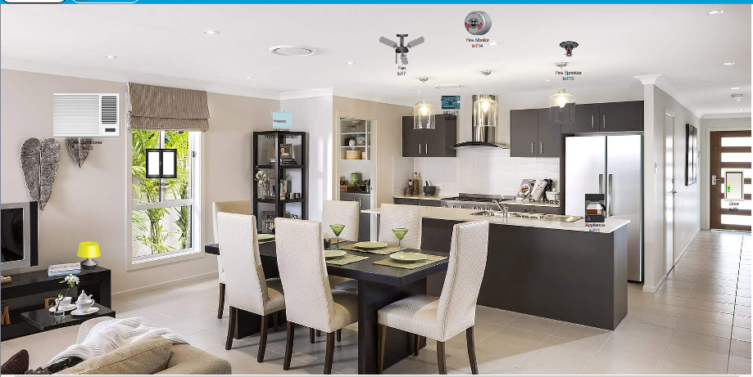

**Step 1: Installing the smart devices**

**Procedure:**

Smart devices used;

* Fan
* Lamp
* Door
* Window
* Coffee machine
* Air conditioner
* Fire sensor
* Fire extinguisher
* MCU
* Home gateway
* Laptop and tablet

We proceeded by doing the following work;

**Act 1:** **Registering the devices on the home gateway.**

We decided to use a wireless connection. That was due to the fact that, using IoT cables made the work a little bit dirty and looking in a cost aspect, wireless links are more beneficiary compared to cables.

To use wireless links, we had some configurations to do on the home gateway as follows:

* SSID = A
* Password = 12345678

Just as shown in the picture below;

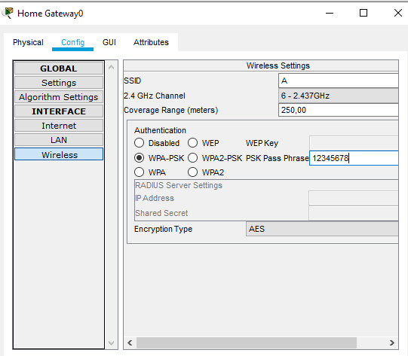

As practical example, we shall show how we registered the IoT devices using the fan.

When we try connecting the fan to the home gateway, we noticed that the fan did not have Wi-Fi card, as shown in the image below;

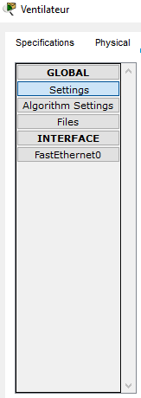

We therefore had to add a Wi-Fi card. For that, we proceeded as follows;

* We double clicked on the fan and accessed the advanced options as shown in the image below;

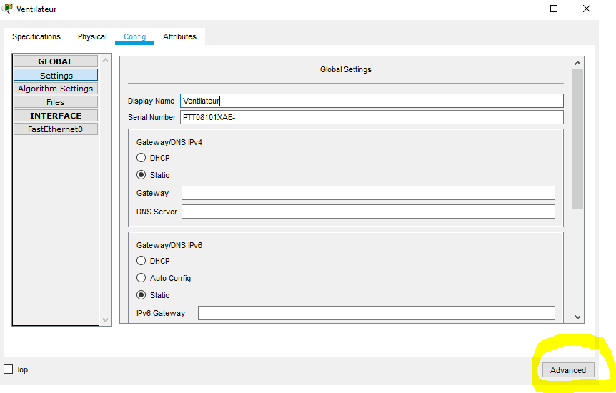

* We accessed the I/O config panel and to the network adapter of the fan, we chose a wireless card. Upon adding that card, it made our fan have access to Wi-Fi services. We did as shown in the images below;

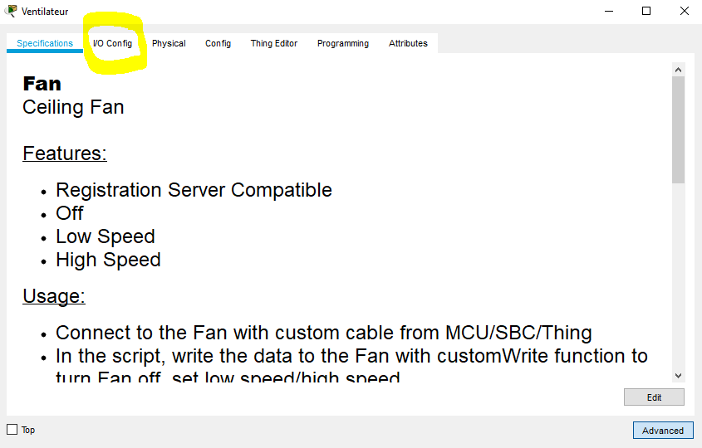

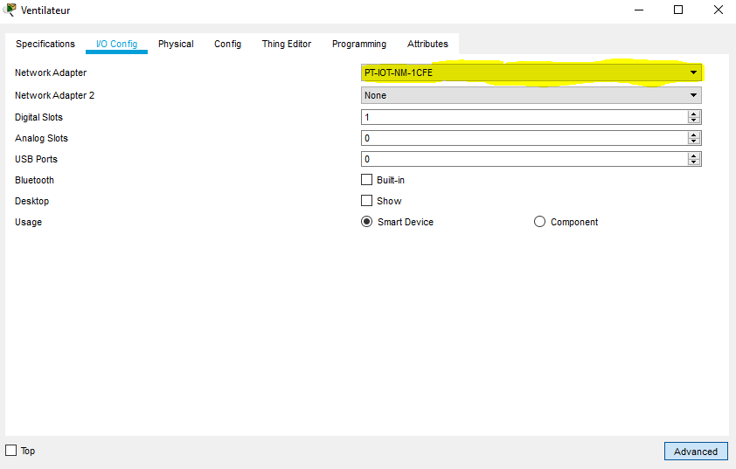

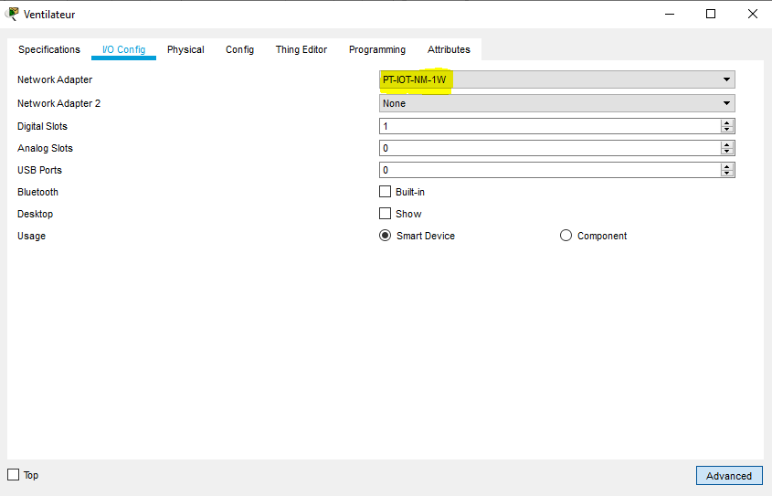

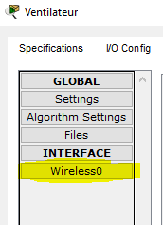

After getting the wireless card, we proceeded to get connected on the home gateway as shown below;

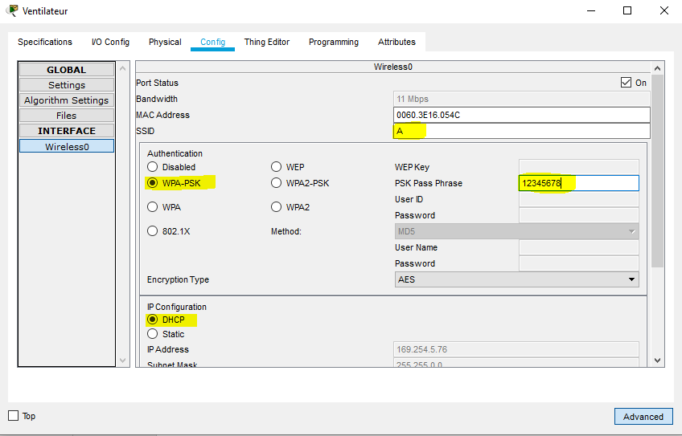

That was how we did for the fan and for every other smart device in the house.

**Act 2: Connecting the Tablet and Laptop to the Wi-Fi**

In order to monitor our smart devices at home or anywhere we needed devices that could get connected to the wireless network created by the Home gateway. So, we used a tablet and laptop for reasons that will be explained as we course through the practical procedure. So, how did we make them get connect to the home gateway?? Let’s begin with the **tablet**.

* The tablet already possessed a wireless card. So, all we did was to configure it to recognize the SSID and the know the password of the of the home gateway. This was done as shown in the image below;

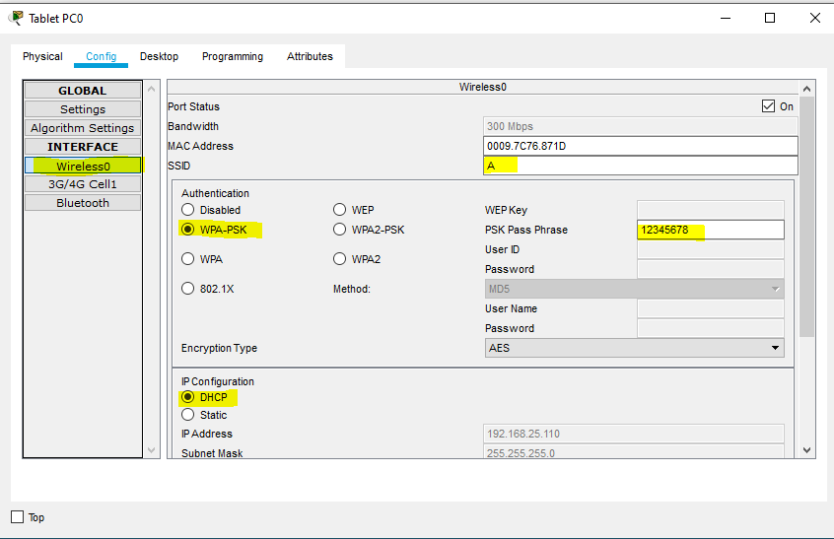

* For the laptop, we had to transform it into a wireless device. Yes, unfortunately the laptop did not have a Wi-Fi card, just as shown in the image below;

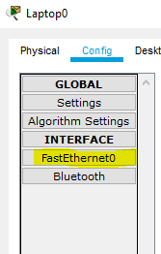

So, we had to add that card. We proceeded as follows;

* We double clicked on the laptop and then clicked on the window named physical.
* We then put off the laptop. Doing that, there is a green light that goes off.
* The idea was to exchange the ethernet card with a wireless card.
* So, we removed the ethernet card. That created and empty slot.
* We then selected a wireless card, carried it and placed on the empty slot.
* After that, we put on the laptop, with the green light coming on, we verified again and there was a wireless card.

All that was done as shown in the images below;

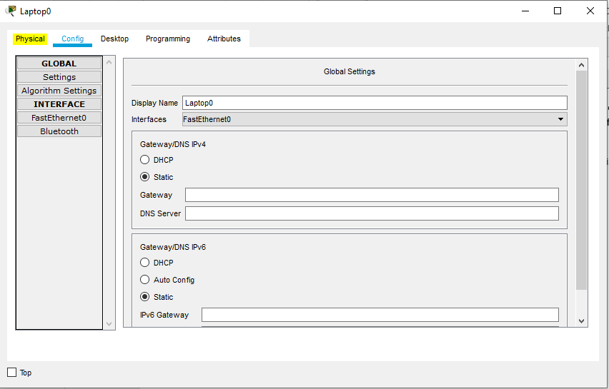

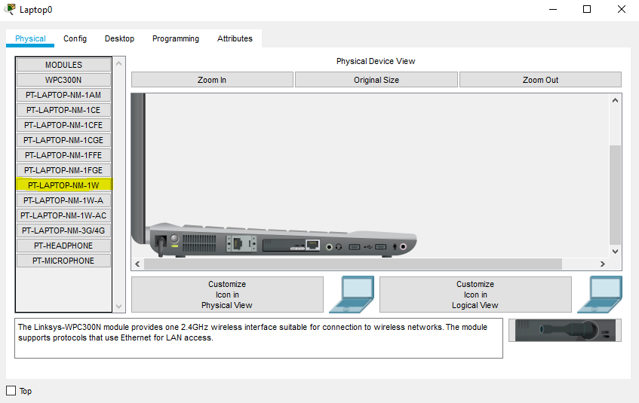

In the picture above, we have found our wireless card. But we can’t replace it if the device is still on.

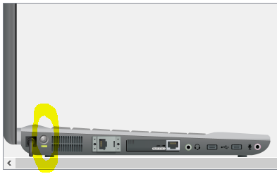

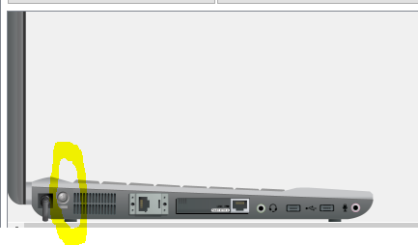

Device off. We proceeded to change the network adapters. This was done as shown in the images below;

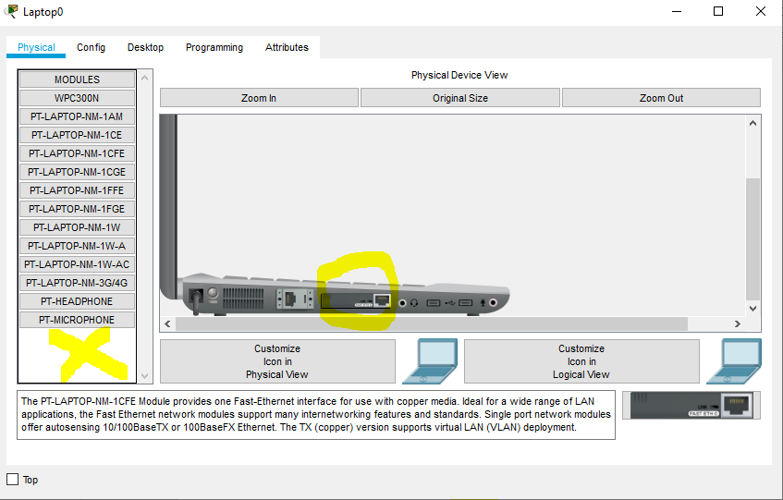

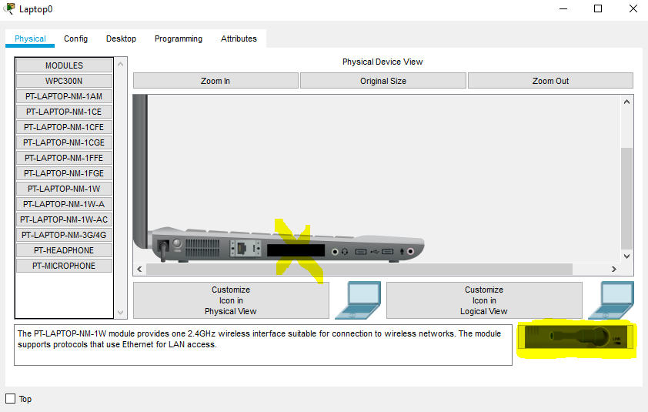

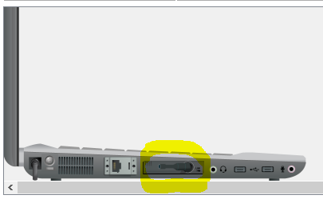

After doing that, we put on the laptop and it had a Wi-Fi card, as shown in the images below;

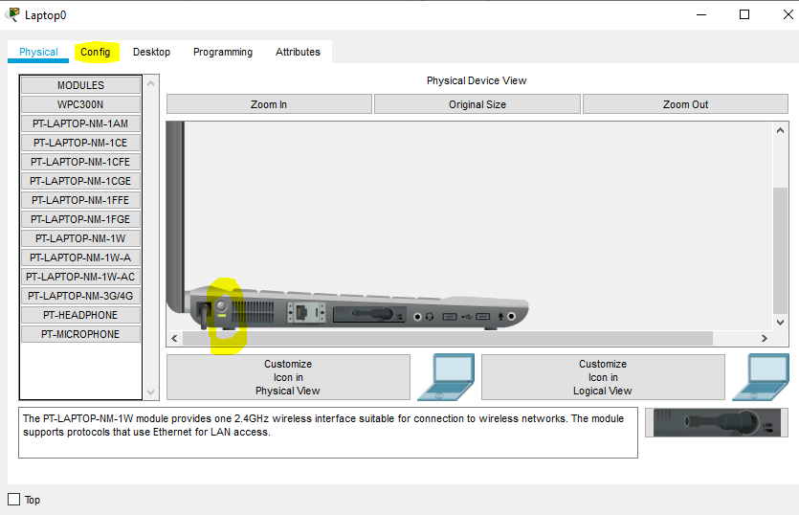

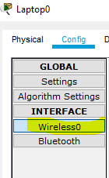

Now that our laptop had a wireless network adapter, all left was to rightly configure it. This was done as shown in the image below;

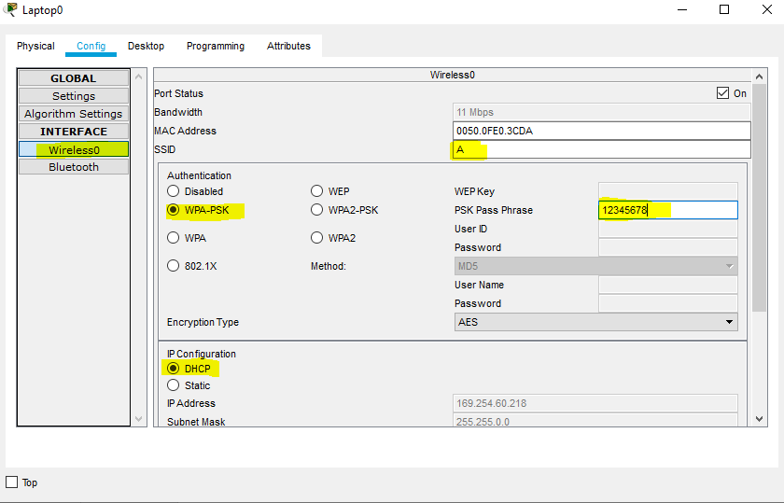

**Act 3: Accessing IoT services through the home gateway.**

This part was to make sure that, any individual could connect to the home gateway, using either the tablet or the laptop.

We did it with that tablet as follows;

* We double clicked on the tablet and clicked on the desktop as shown in the image below

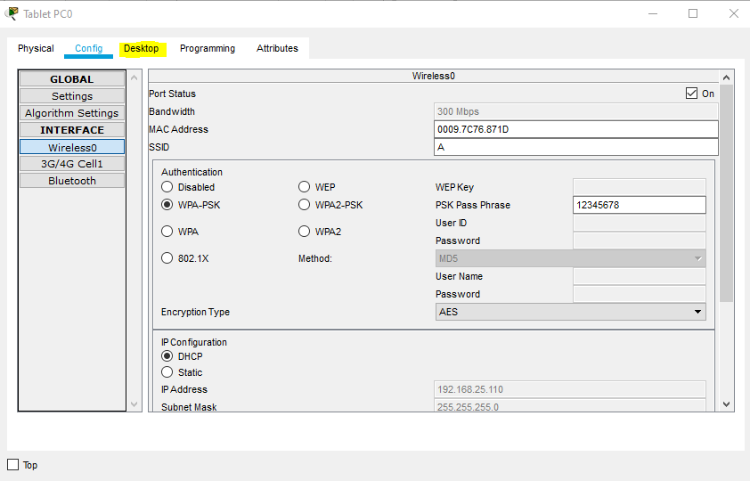

* In the desktop window we clicked on IoT monitor as shown in the image below

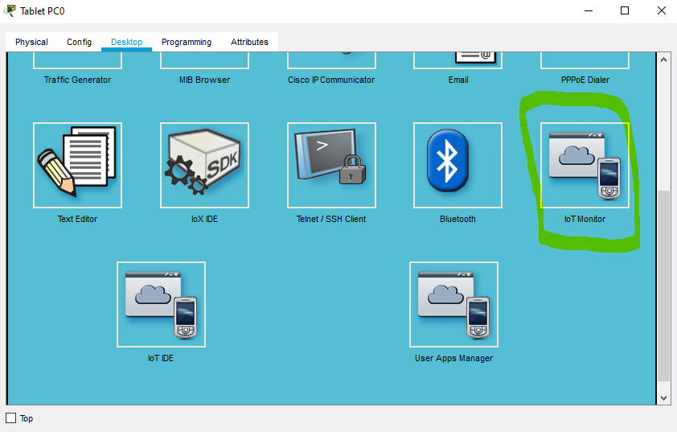

* Upon doing that, we logged in to the IoT server as shown in the following images;

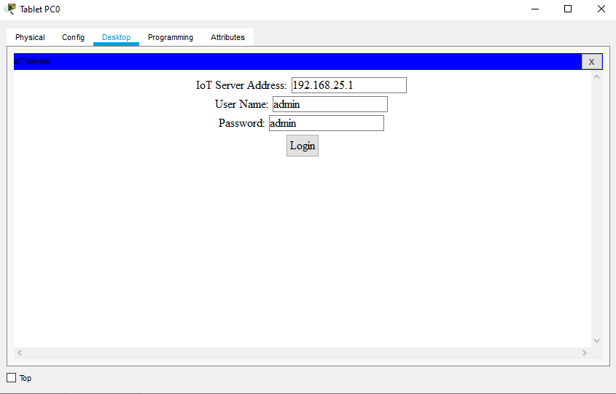

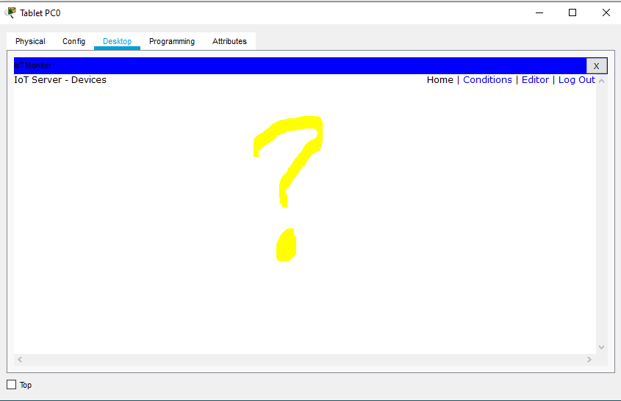

One remarked that there were no IoT devices. Meaning, no device was registered.

**Act 4: Registering IoT devices**

Still as example we decided to use the fan. So, to register that we double clicked on the fan, went to the config window and scrolled down to the IoT server and selected home gateway, just as shown in the images below;

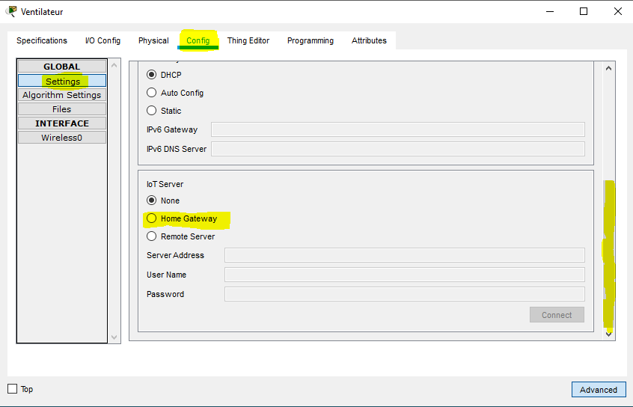

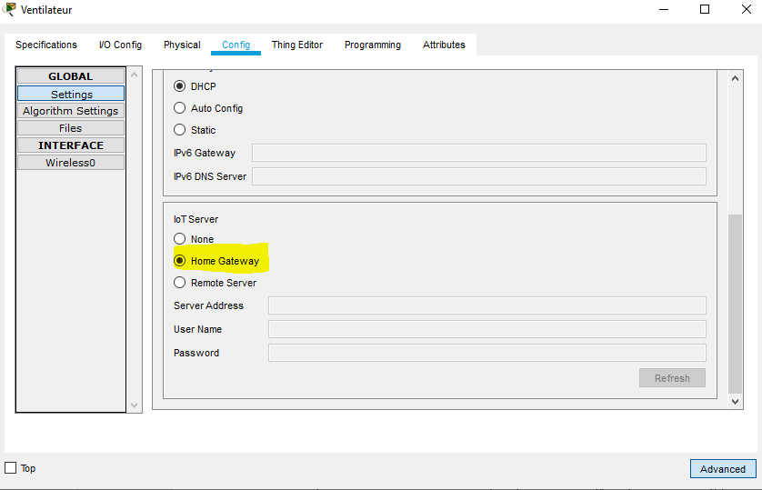

That is sufficient to register an IoT device, and registering all of the devices gave us the following image,

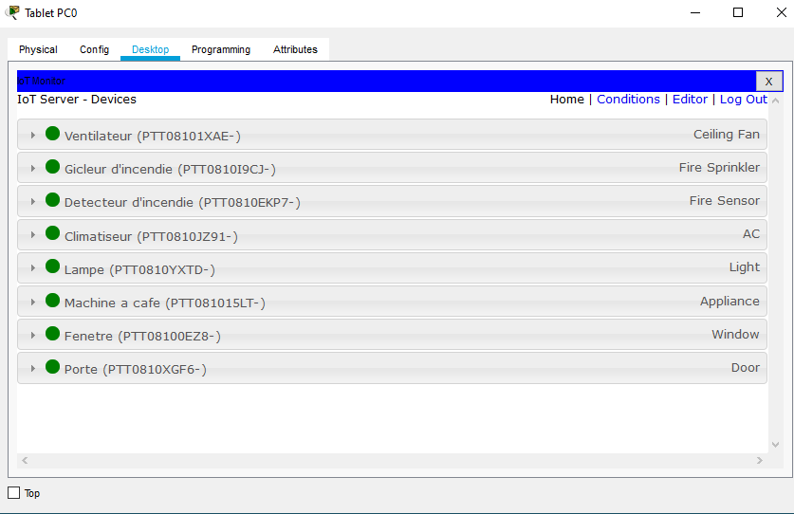

**Step 2:** We now supposed that, the house belonged to a certain Mr MOMO, who required the services of a telecom company ‘PLUTO’ and also internet service provider to be able to monitor his devices when not home. That is from a distant place.

**Topology**

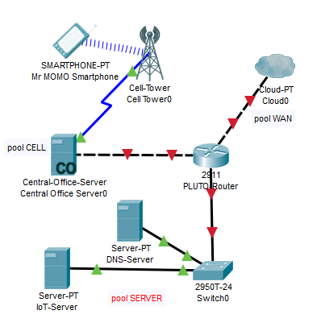

The topology above shows how we designed the cloud for internet. The internet cloud content was:

* Momo Smartphone
* BTS
* Central office
* DNS server
* IoT server
* Switch
* PLUTO router
* Cloud

**Act 1: Cloud configuration**

We configured the DHCP service on PLUTO-router as follows;

* We defined the following DHCP pools;

**POOL 1** : SERVER

ip dhcp pool SERVER

network 10.0.0.0 255.0.0.0

default-router 10.0.0.1

dns-server 10.0.0.254

**POOL 2** : WAN

ip dhcp pool WAN

network 209.165.200.224 255.255.255.224

default-router 209.165.200.225

dns-server 10.0.0.254

**POOL 3** : CELL

ip dhcp pool CELL

network 209.165.201.224 255.255.255.224

default-router 209.165.201.225

dns-server 10.0.0.254

For each of the pools, we reserved the following addresses;

**POOL 1 :** SERVER

ip dhcp excluded-address 10.0.0.1 10.0.0.5

**POOL 2 :** WAN

ip dhcp excluded-address 209.165.200.225 209.165.200.229

**POOL 3 :** CELL

ip dhcp excluded-address 209.165.201.225 209.165.201.229

**NB:** All these configs were done in the global mode.

We now configured the interfaces:

**POOL 1** : **SERVER**, connected to interface GigabitEthernet 0/0

interface GigabitEthernet0/0

ip address 10.0.0.1 255.0.0.0

no shutdown

**POOL 2** : **WAN**, connected to interface GigabitEthernet 0/1

interface GigabitEthernet0/1

ip address 209.165.200.225 255.255.255.224

no shutdown

**POOL 3 : CELL**, connected to interface GigabitEthernet 0/2

interface GigabitEthernet0/2

ip address 209.165.201.225 255.255.255.224

no shutdown

We went further to configure the servers

* The DNS server was configured statically and the DNS service activated as shown below,

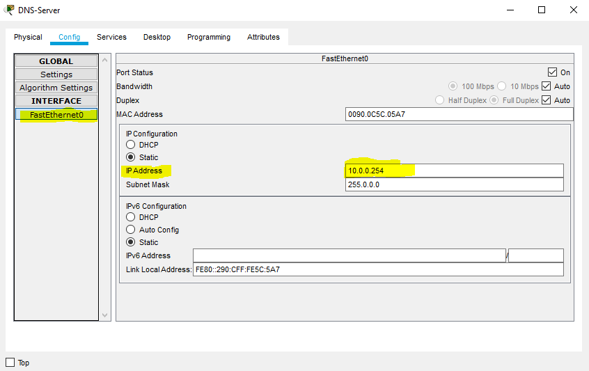

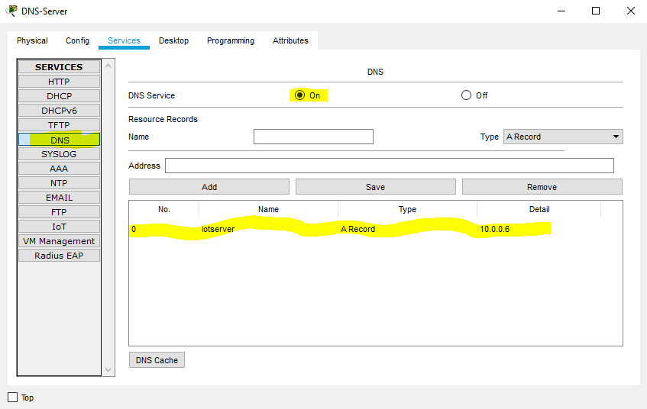

* The IoT server was dynamically addressed and the IoT service was activated as shown below;

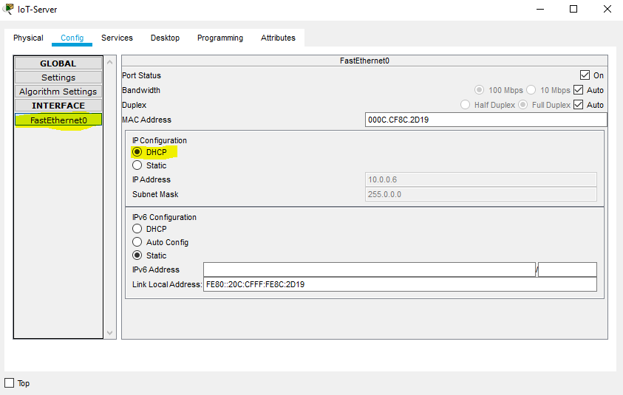

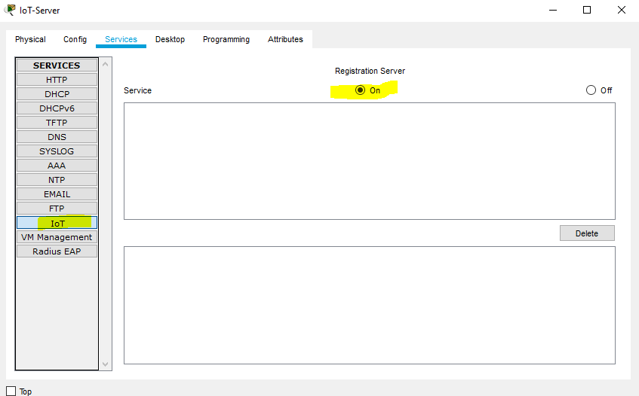

* The central office was dynamically addressed, as shown below;

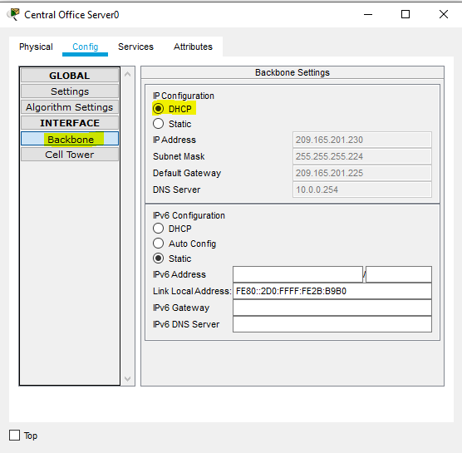

* The PLUTO-router connected to the cloud provides internet services and its connections were as follows

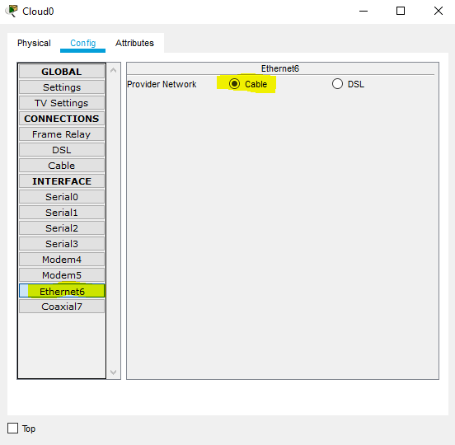

The PLUTO-router was linked by a cross cable to the cloud

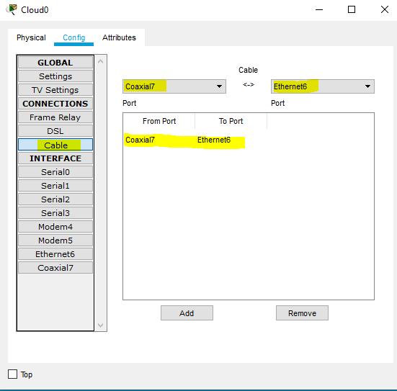

All, that is left was to connect the house to the internet.

**Act 2: Connecting The Internet to the House**

This was done by connecting the Home gateway to the modem by a straight cable. That modem in turn was connected to a coaxial splitter which was connected to the cloud as shown in the image below;

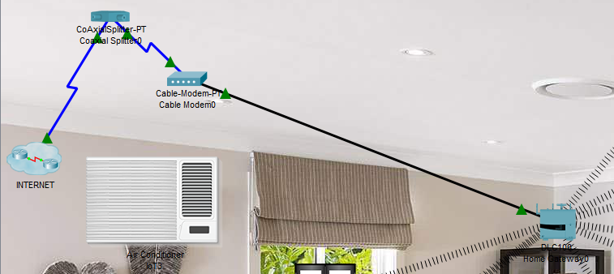

**Act 3: Registering the smart devices on the IoT server found in the cloud**

As example we did that, using the fan again.

* We started by creating an account in the IoT server using the laptop as shown in the images below.

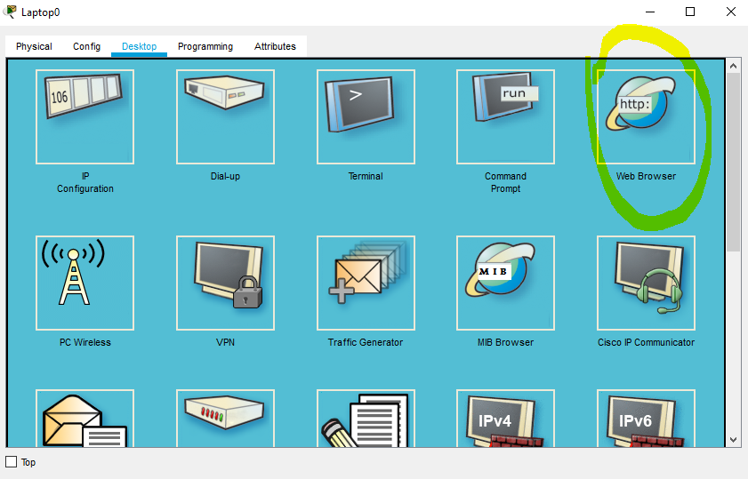

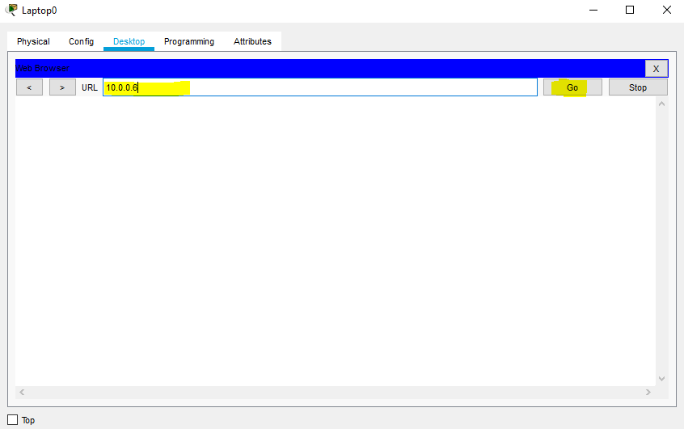

The address entered above, is the server Ip address. It gives us access to the default account page of the server. Accessing that page, we signed up a new account as shown below;

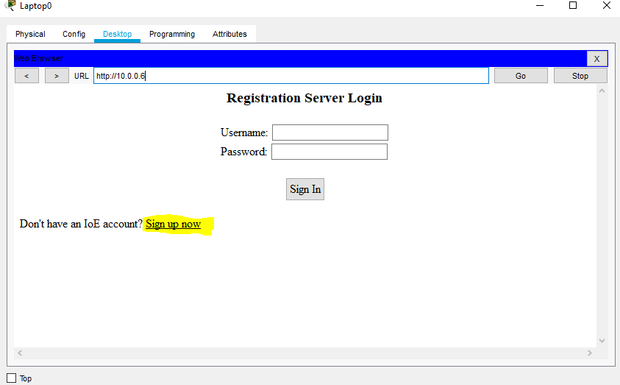

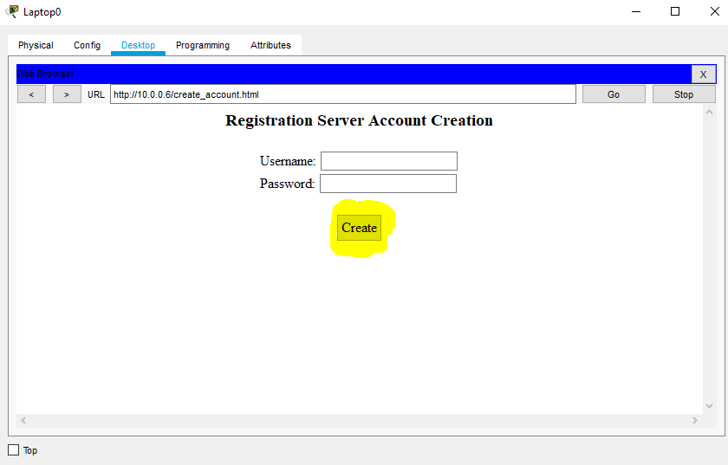

We created an account and upon accessing it, it was empty, showing that no equipment had been registered.

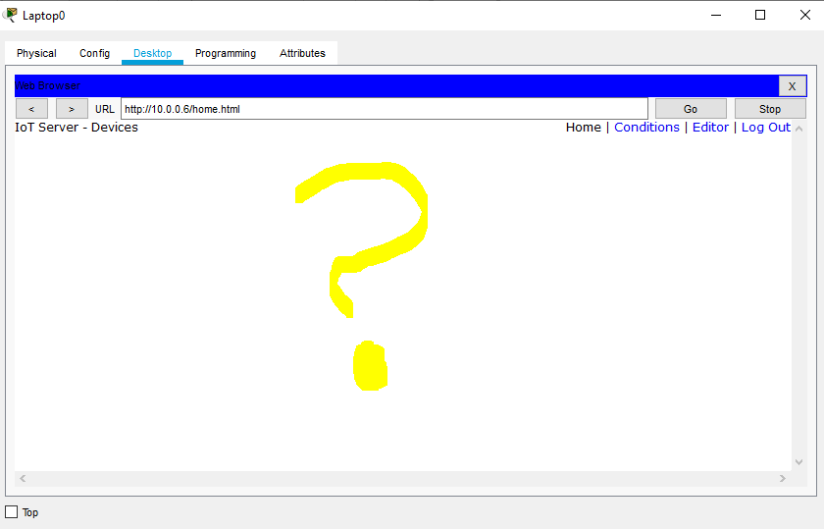

We registered the fan as shown below;

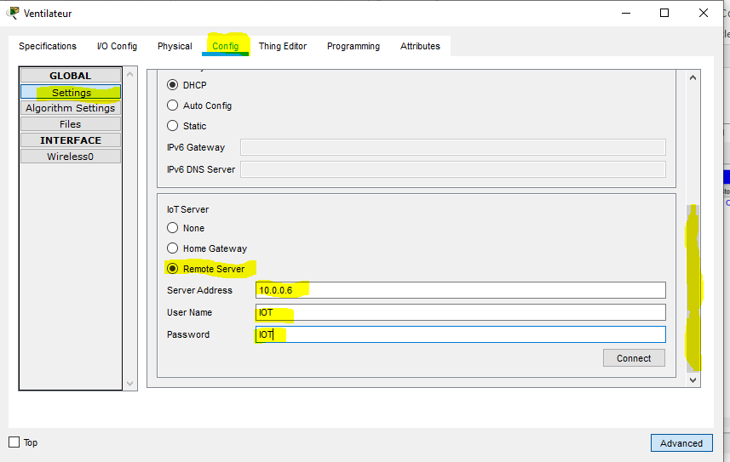

The user name and password were left for us to decide and we could have used anything. When the fan was registered, we could now monitor it using our laptop as shown in the image below;

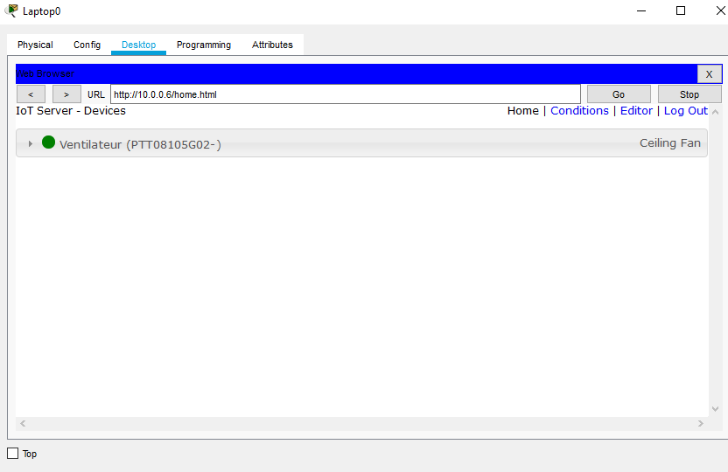

Now that the phone and other devices were registered, we used Mr MOMO’s phone to connect to the internet and check whether will could also monitor the equipment.

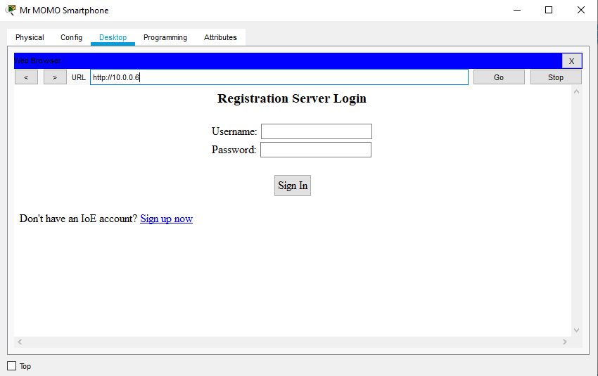

When Mr MOMO signed in, he obtained the following

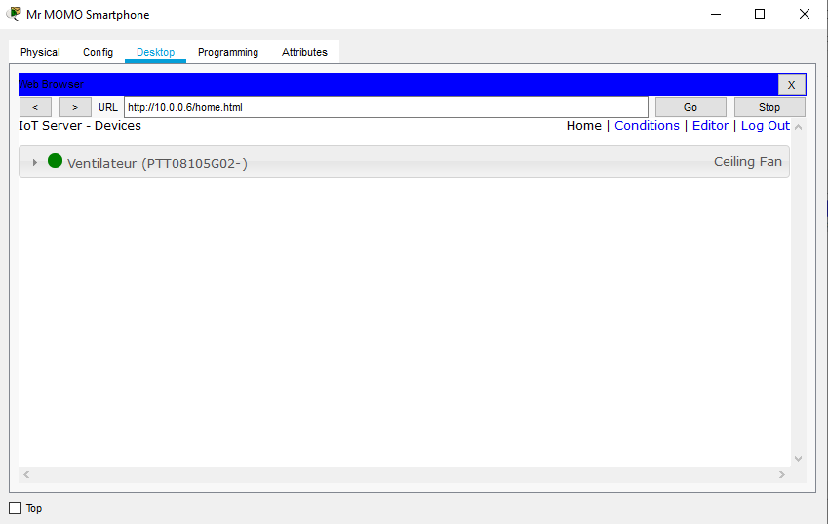

It was successful. Hence, where Mr. MOMO is found, he can monitor the states of his smart devices at home.

**PRACTICAL 6: EXPLORING A SMART INDUSTRY**

**Main Idea:** The idea is just as that of the smart home. Rendering the industry intelligent, being able to monitor the devices and the stocks in the industry from a distant office

The procedures are just as for the smart home, so only the results shall be presented below.

**Act 1: Central Office of the RHOLY Corp.**

**Topology**

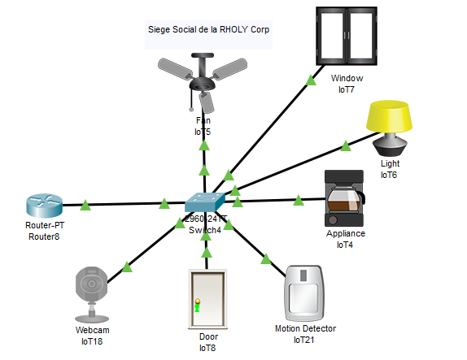

**Act 2: The RHOLY Corp’s warehouse**

**Topology**

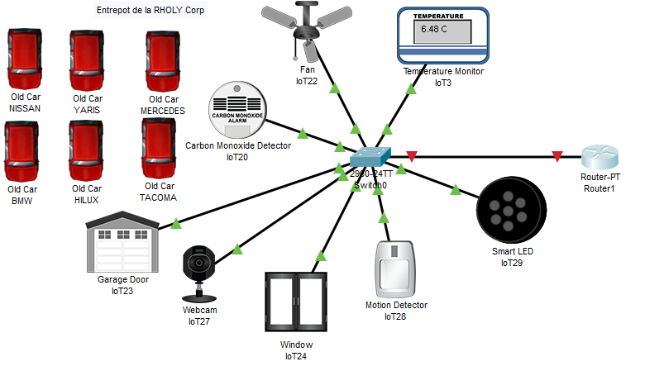

**Act 3: RHOLY Corp’s Data Centre**

**Topology**

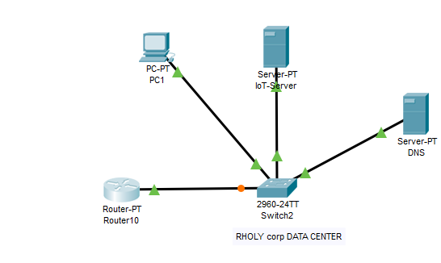

**Act 4: Interconnection of the different units**

It was done at the level of the Router-PT of each unit. It was from those routers that we established a leased line (serial link) between each independent units. This gave the result below.

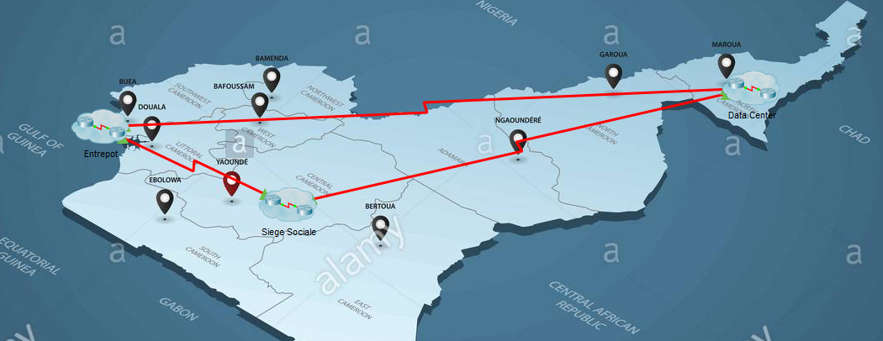

When all devices are registered on the IoT server, monitoring them from any site becomes feasible. When monitored from laptop 0, we got the following result;

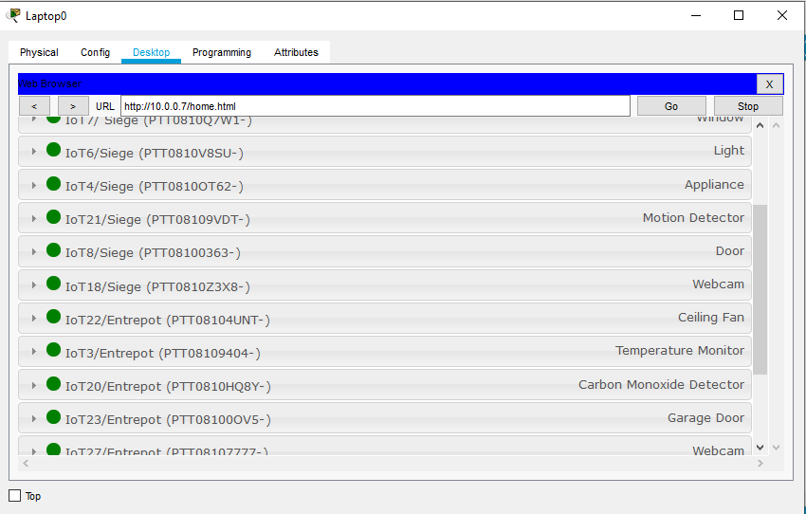

**PRACTICAL 7: BASIC SECURITY MEASURES FOR IoT SYSTEMS**

**Topology**

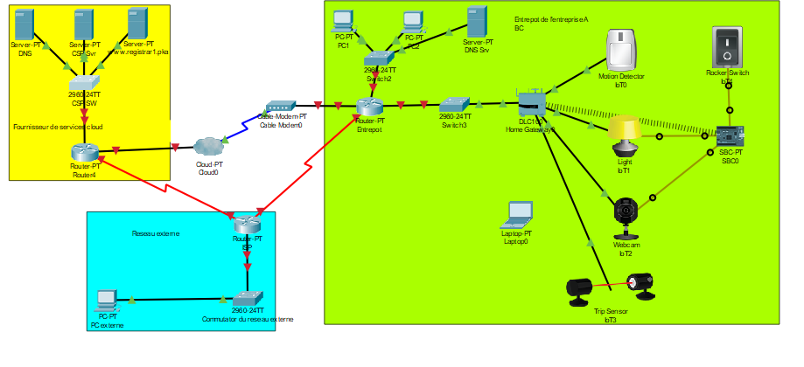

**Main Idea:** The idea here was to render the system above more secured. In terms of security the idea was to add access control lists, render the authentication on network stronger, insert surveillance cameras etc.

**Step 1:** **Configuring the Network**

Configuring Cloud service provider server. They were configured statically.

* The DNS server was configured as such;
* We first statically inputted the Ip address.
* We defined the gateway address
* Lastly, we activated the DNS service and entered the server’s name. This gave the following results below

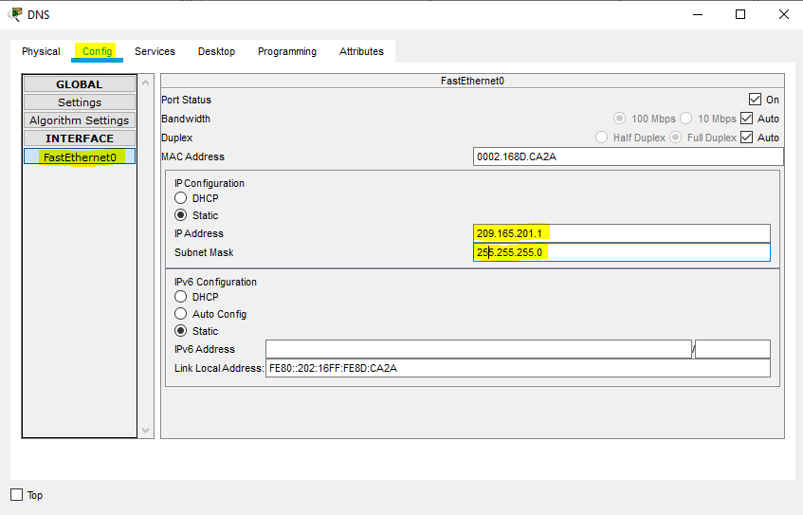

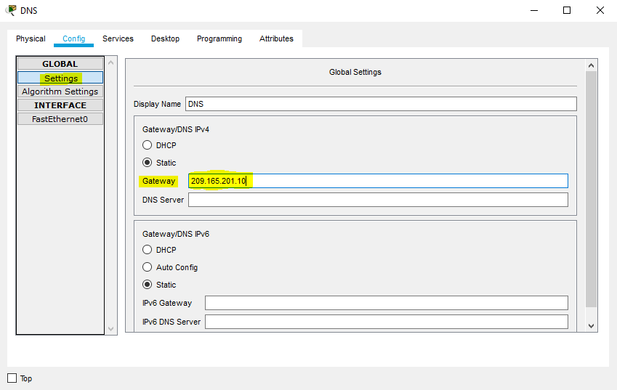

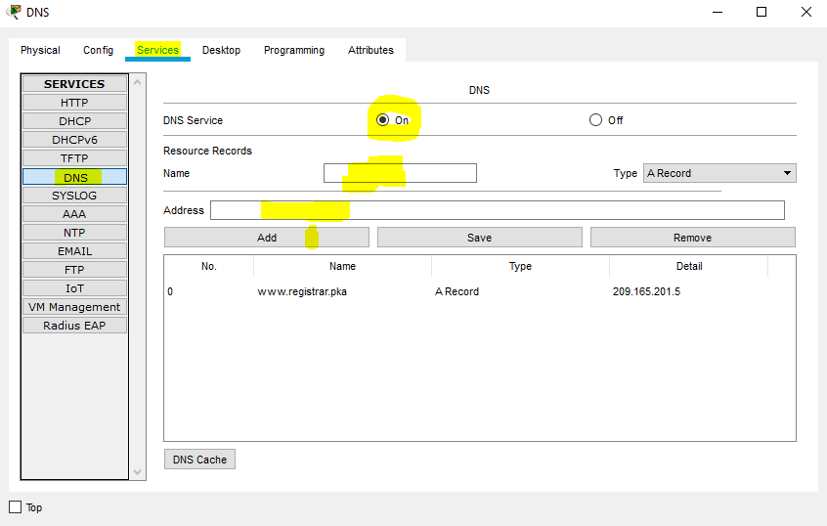

* For the CSP sever we also configured it statically, as shown below

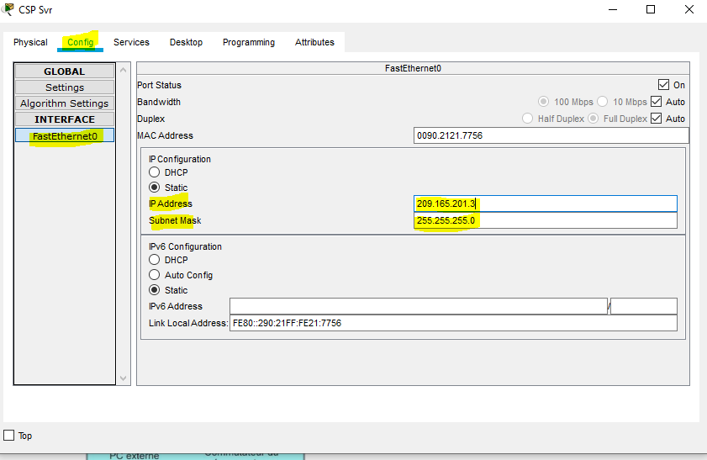

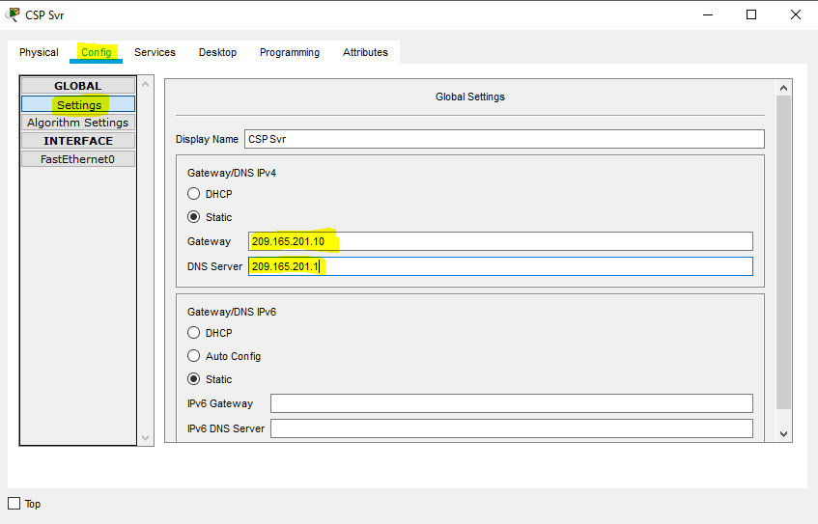

* We configured the registry server. Just as the DNS server, the configurations were pretty the same. This was done as shown below;

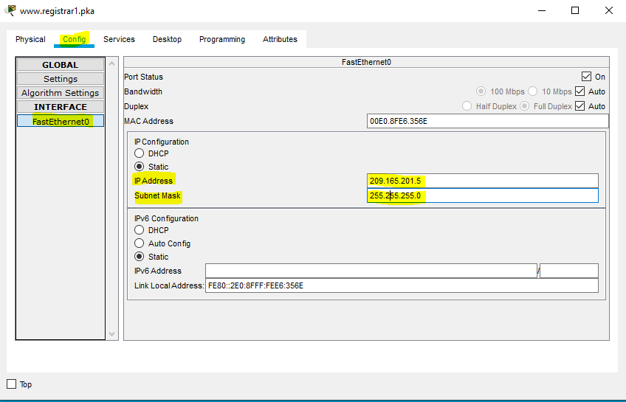

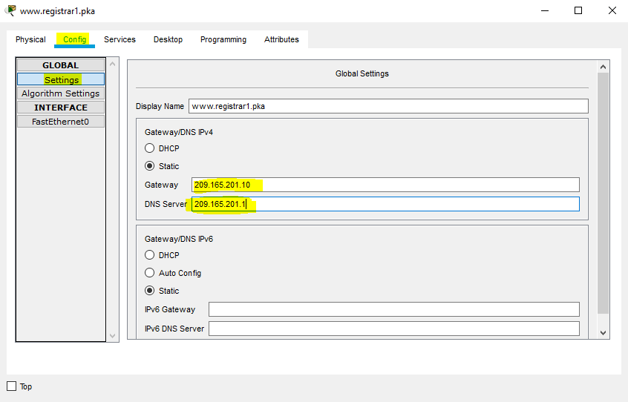

* We further proceeded to configure the interfaces of each router present in the topology. This was done as follows;

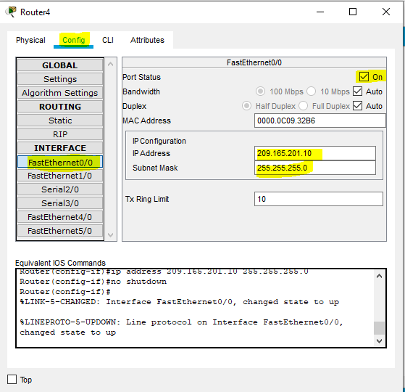

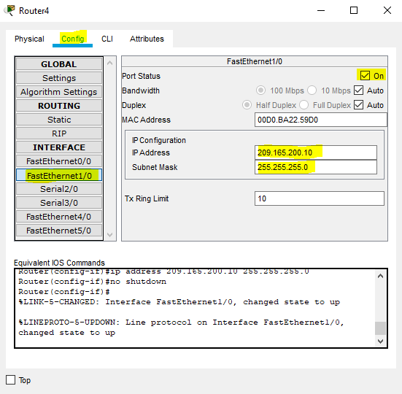

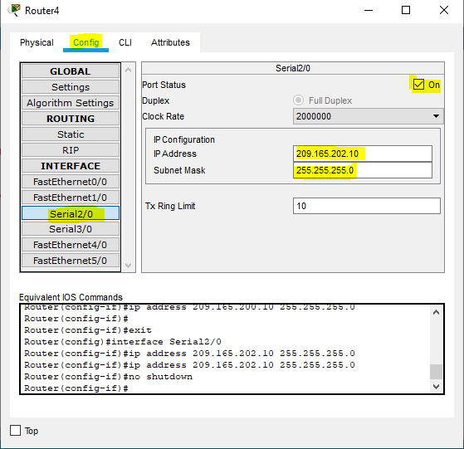

And for a communication between the routers and the rest of the networking devices, we specified the static routes, as shown below

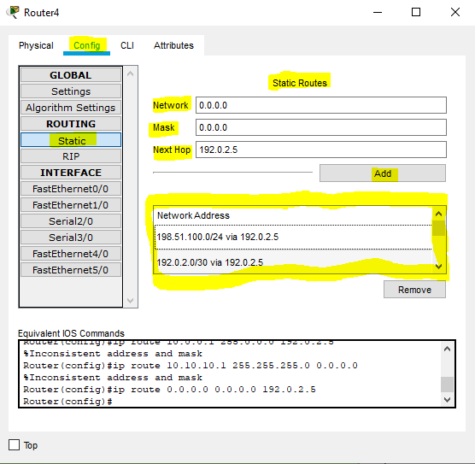

* We configured the cloud too, just as we did in the previous practical as shown below;

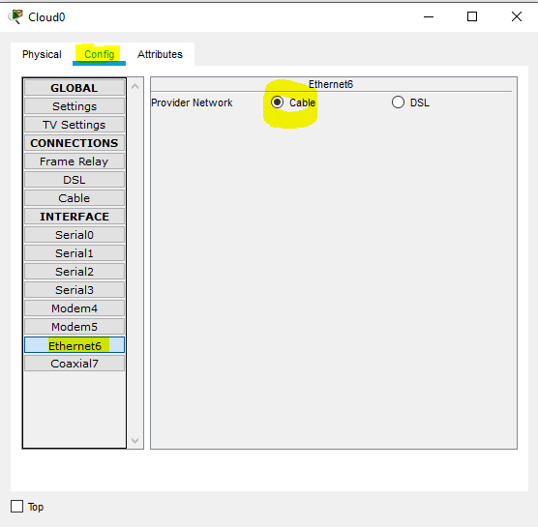

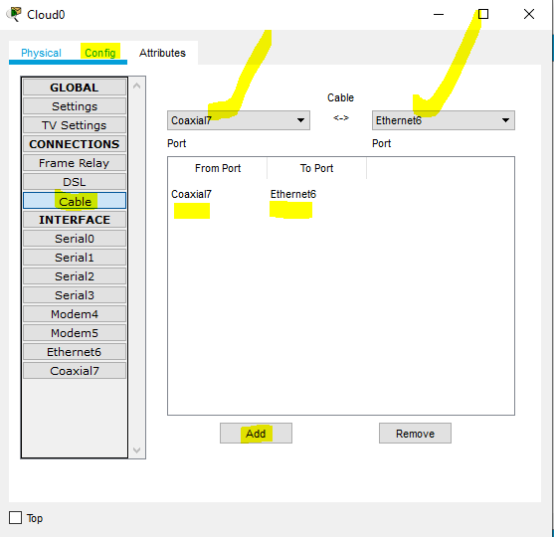

* After the cloud, we were left to configure the PCs, the ISP router, the devices in the warehouse (entrepot).
* The configuration of the external PC was done as shown in the images below.

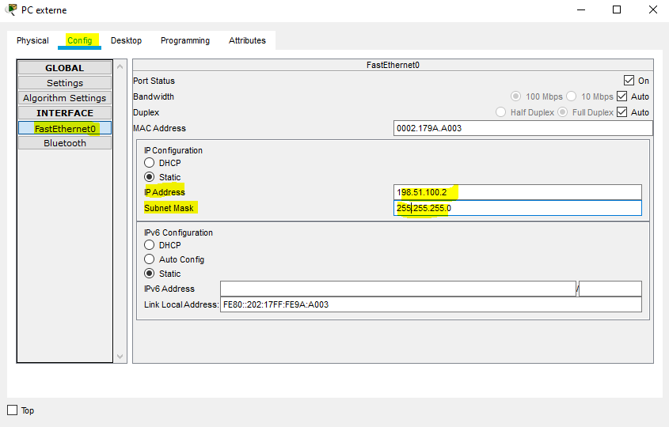



* For any PC (external) to monitor the ware house, there should exist an internet connection. The following images show the configuration of the ISP router.

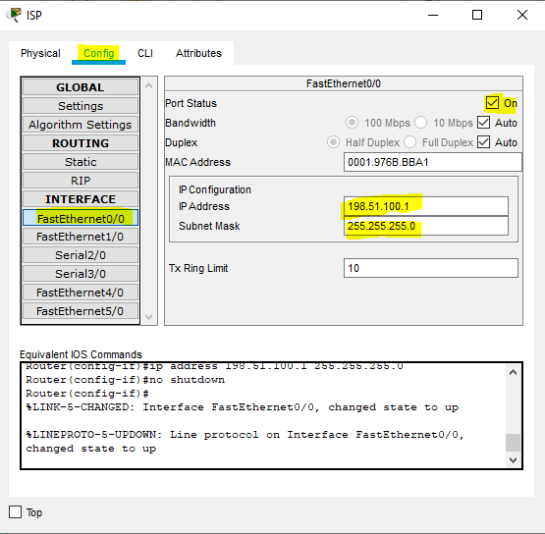

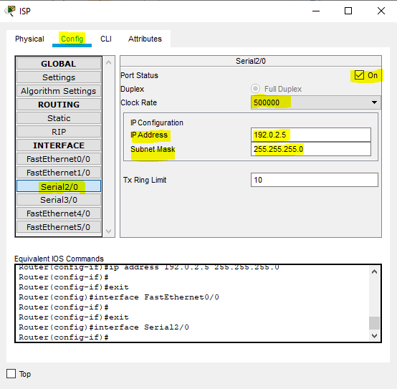

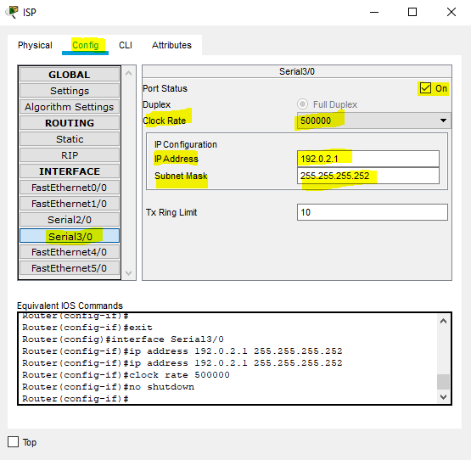

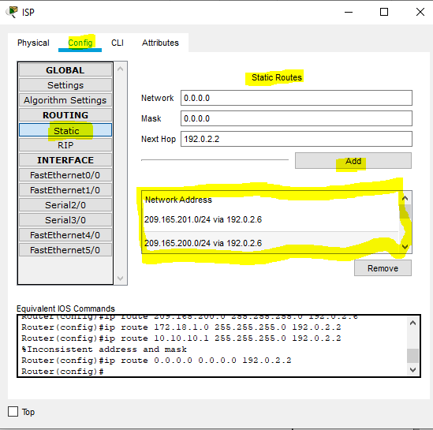

* At the level of the ware house, a router was put in to place for the any device to be able to communicate too with the other units. The router called entrepot was configured as shown below.

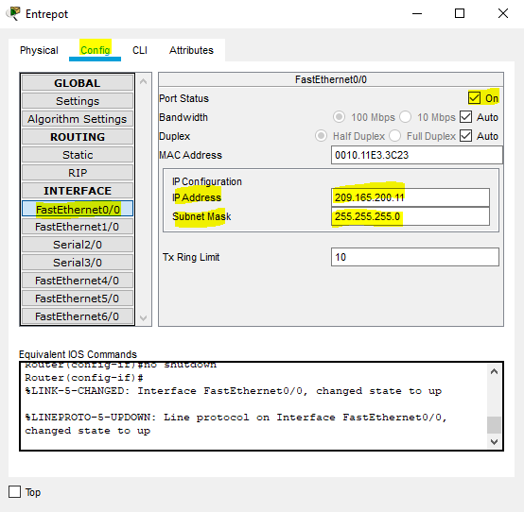

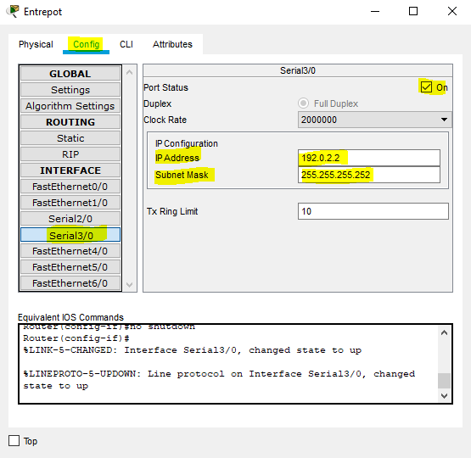

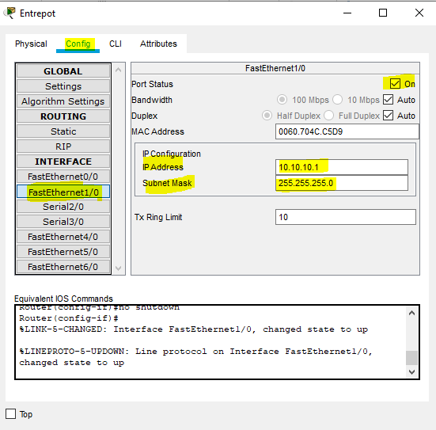

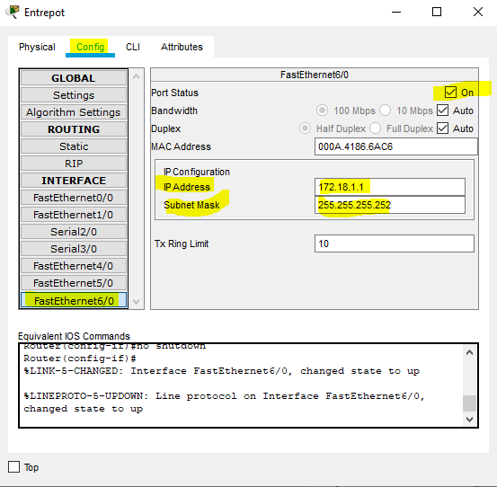

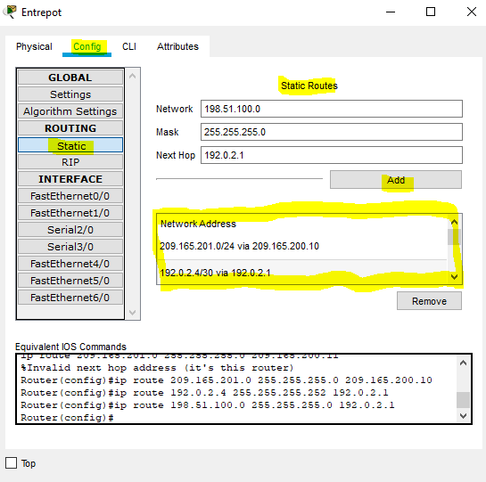

* With the ISP router configured, it means the PCs in the ware house can actively communicate with the other units. Thus they were configured as follows;

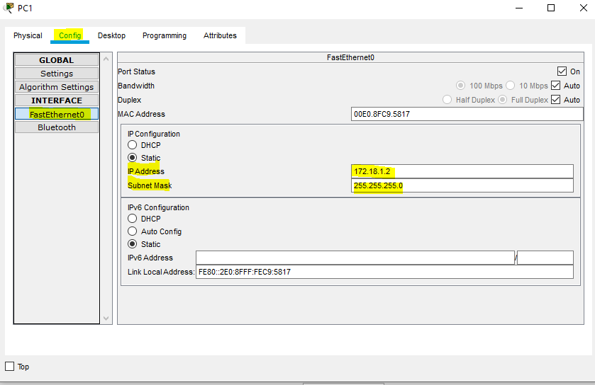

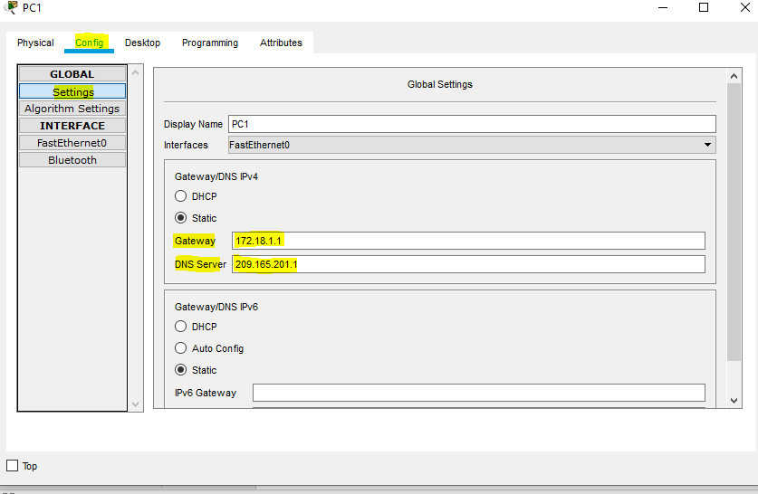

* This same configs were used for PC-2. With the PCs configured, we were left with the gate way through which the IoT devices shall be registered. We there fore configured the Home gateway. The home gateway was configured as shown below;

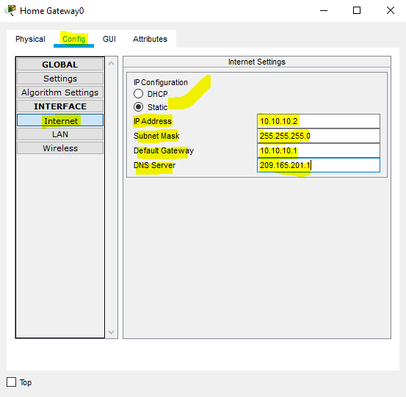

* Now that, the home gateway was configured, we had to register the equipment on the registration server. We first activated the IoT service on the register and checked if it worked. The result was as shown below

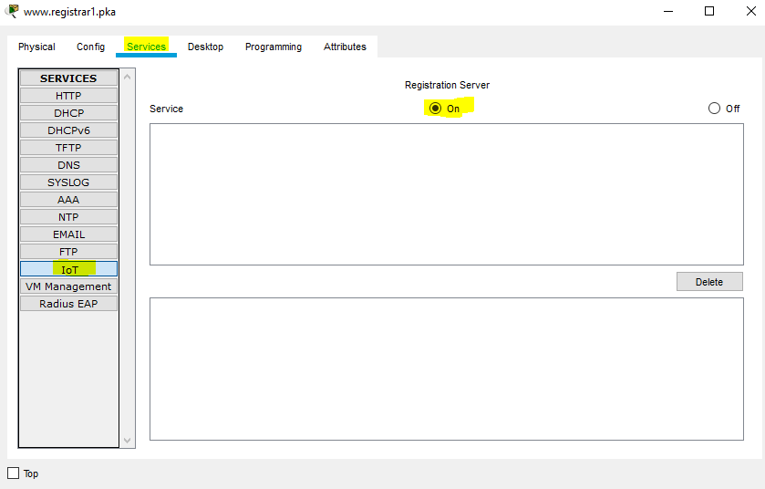

Upon checking the IoT service, it worked. The result shown below, was done using the laptop to verify if it could access the registration server, and it worked.

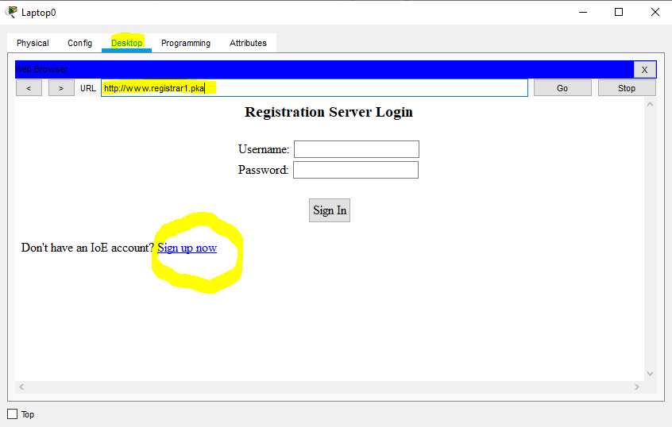

* We created an account at the level of the server and registered the IoT devices to the server. We just showed one IoT device as example in this work. Creation of account first;

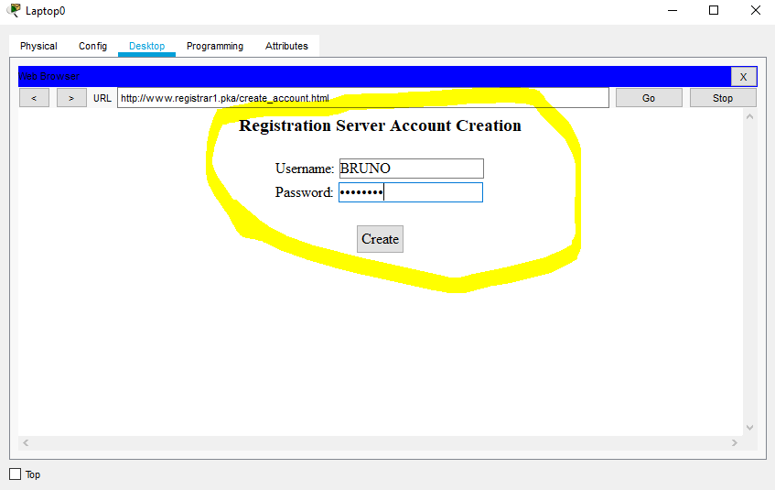

Then registering the devices on the registration server;

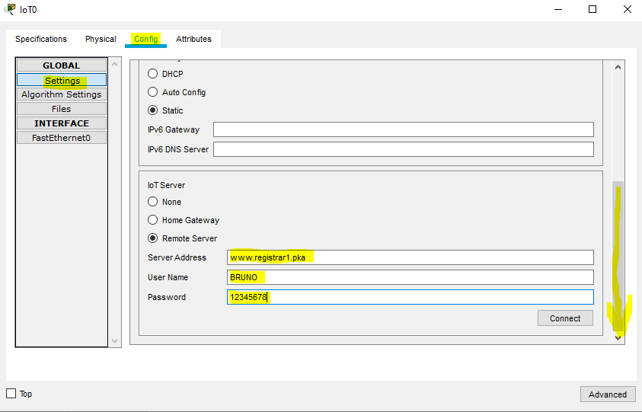

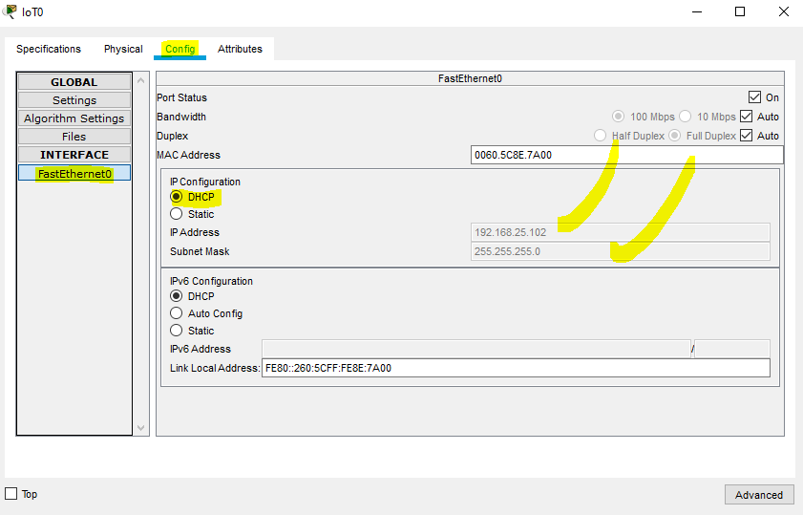

After that, from the laptop we checked if the device was well registered at the level of the server. This gave the following result,

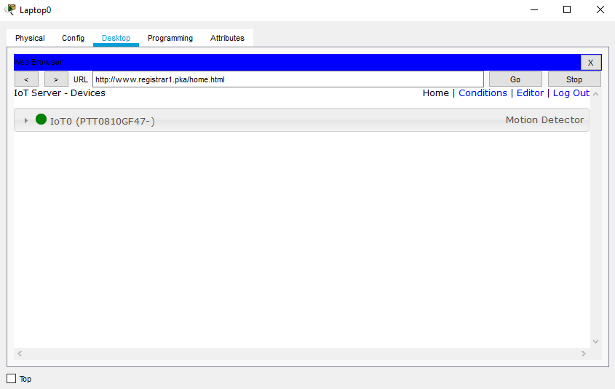

* All that was done above was just the formalities. Registering the devices and all the configurations was for the network to be functional, the security part was not touched. The lines below will access some security aspects.
* The minimal security touch was at the level of the home gateway. On the home gateway we inputted a password at the level of the wireless access points.

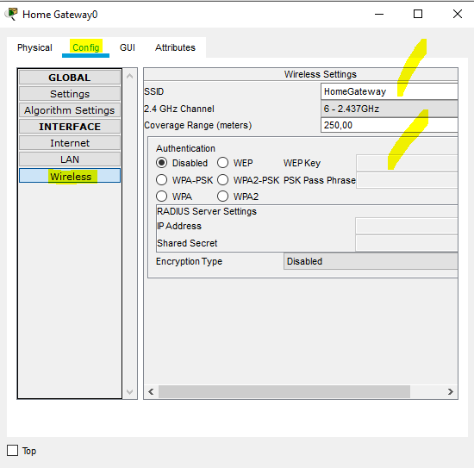

* The motion sensor, needed to be more precise. It had to signal us in case there is an unauthorized access. This was achieved by the following code;
* **Router>en**
* **Router#conf t**
* **Enter configuration commands, one per line. End with CNTL/Z.**
* **Router(config)#banner login %Login with valid password%**
* **Router(config)#banner motd %Authorized Access Only! Tout accs non autoris est Enter TEXT message. End with the character '%'.**
* **passible de poursuites pnales.%**
* **Router(config)#**
* We inputted a pass phrase using the following code;
* **Router(config)#enable secret bonjour**
* **Router(config)#exit**
* In case we wanted to get connected online as an admin, we configured some virtual terminals, using the following code.

**Router#en**

**Router#conf t**

**Router(config)#username ketch secret ktar**

**Router(config)#line console 0**

**Router(config-line)#login local**

**Router(config-line)#exit**

**Router(config)#line vty 0 4**

**Router(config-line)#login local**

**Router(config-line)#end**

* At the level of the router-entrepot we designed an access control list to render it selective and more secured. This was done using the following codes;

**Router#conf t**

**Router(config)#access-list 10 permit host 172.18.1.5**

**Router(config)#access-list 10 permit host 209.165.201.5**

**Router(config)#access-list 10 permit host 172.18.1.4**

**Router(config)#interface fastEthernet 0/0**

**Router(config-if)#ip access**

**Router(config-if)#ip access-group 10 out**

**Router(config-if)#end**

* We did the same at the level of the cloud service provider router at the level of the company using the following codes.

**Router # configure terminal  
Router (config)# access-list 110 permit ip host 209.165.200.11 host 209.165.201.5  
Router (config)# access-list 110 deny ip any host 209.165.201.5  
Router (config)# access-list 110 permit ip any any  
Router (config)# interface f0/0  
Router (config-if)# ip access-group 110 out  
Router (config-if)# end  
Router #**

* To close it, at the CSP server we rendered the web HTTP service secured by choosing a secured version of HTTP, which is HTTPS, as shown below;

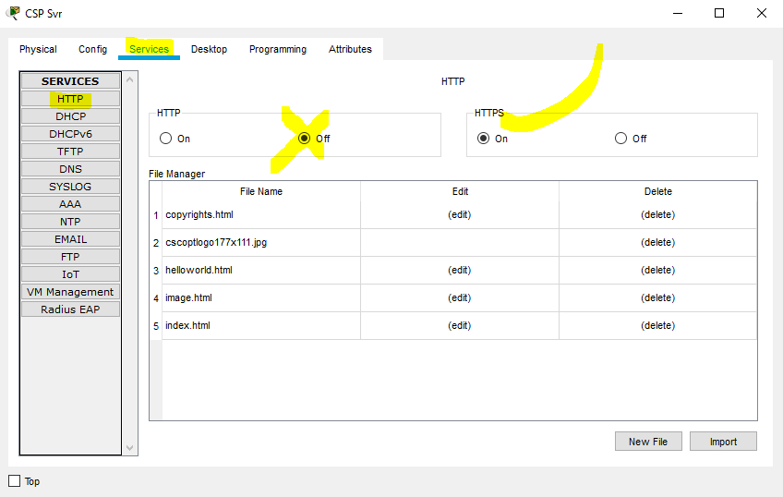

**PRACTICAL 8: EXPLORING A SMART CITY**

**Main Idea:** The scenario is going through a connected city. Designing one’s own ideal city and linking each important compartment of that city through an internet connection. Rendering monitoring of the units easily and practically at all points or internet points of the city by certain administrators.

This practical is based on all the notions learned in the previous practicals.

**Units of the city;**

* Telecom network
* Adamou electrics
* Mr. MOMO’s Flat room
* Street lamp
* Parking

**Topologies:**

**Telecom Network**

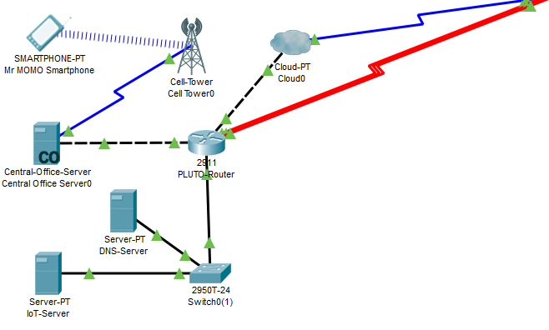

**Adamou electric**

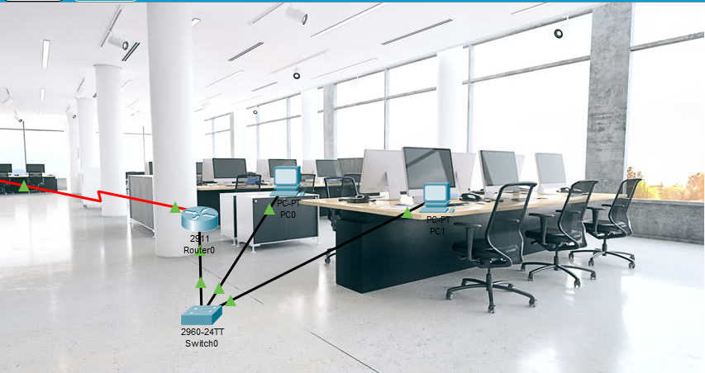

**Mr. MOMO’s Flat room**

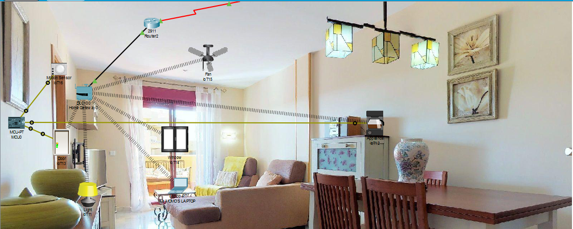

**Parking**

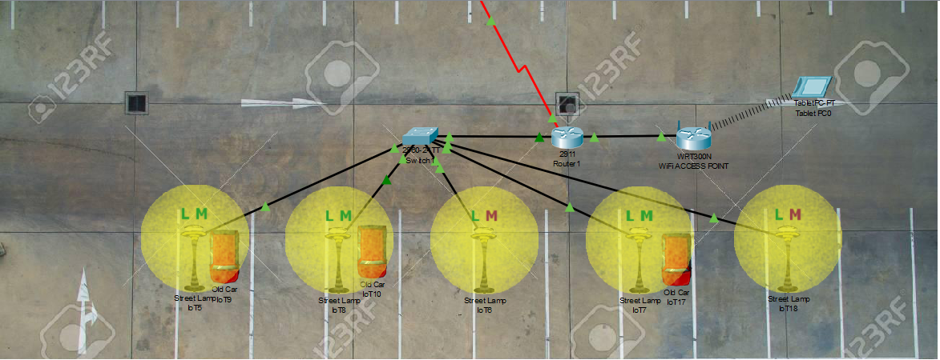

**Street Lamp**

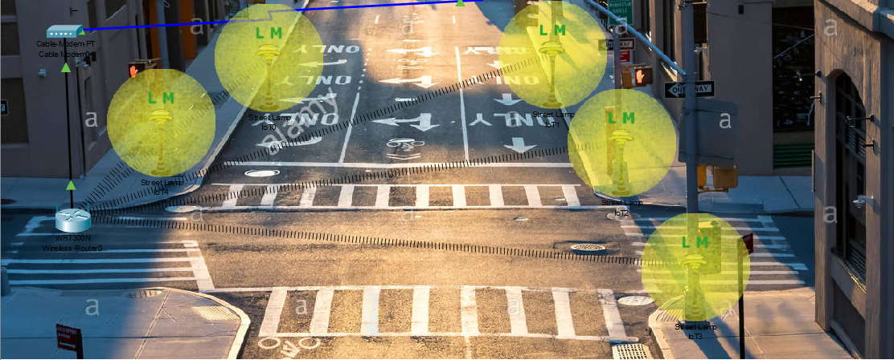

**General view**

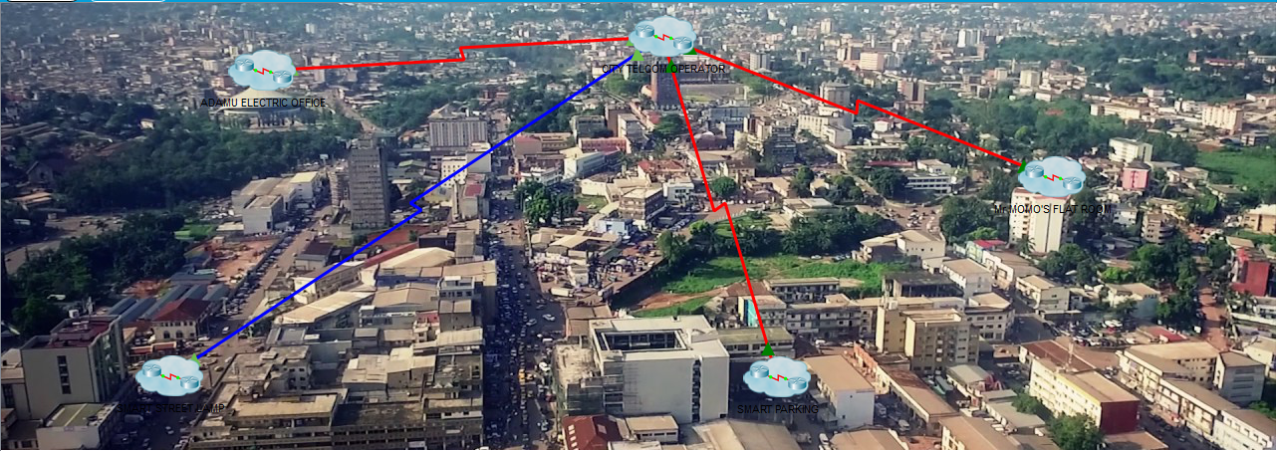

Detailing this practical, that is, how we configured or how we created this topology was not necessary because this practical was based on the notions already fully explored in the previous works done above.

The solution itself is better viewed on the videos attached to this report.

**PRACTICAL 10: STUDY CASE AND PROTOTYPING**

**Main Idea:** The scenario here is that of a garage door which is not smart and the idea is to know the state of the door either locally or distantly. In order to achieve that we use a microcontroller with the role of detecting the information with respect to the garage’s door state (open or closed) and to transmit this information to a distant server to which it is connected.

Component parts of our study case;

**LAN part;**

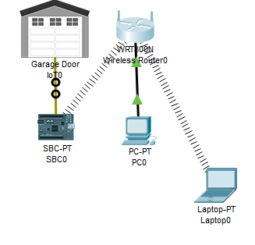

**WAN Part;**

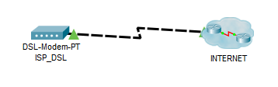

**Internet inside**

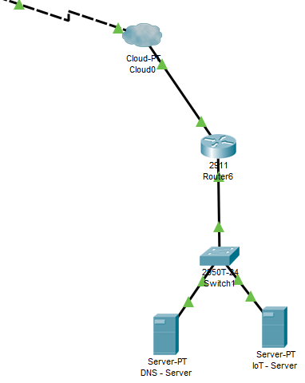

**Wifi access point**

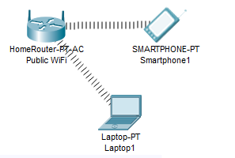

**General View**

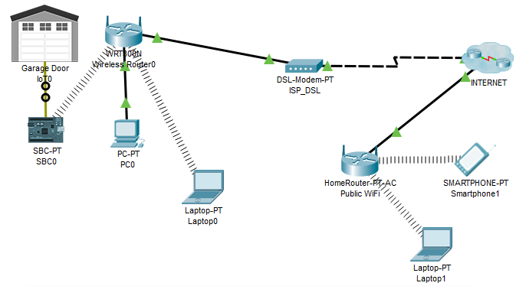

That was how the topology was presented for the study case. The configs of the end devices were done as usual (referring to the previous practicals). What we really retained and is explained below is how the microcontroller was transformed in to a sensor that will immediately report the state of the door garage to the server which can then be checked by a monitoring device.

A java script code was written as follows;

var state = 0;

function setup() {

IoEClient.setup({

type: "GarageDoor",

states: [{

name: "STATUS",

type: "bool",

controllable: true

}]

});

IoEClient.onInputReceive = function(input) {

processData(input, true);

};

attachInterrupt(0, function() {

processData(customRead(0), false);

});

setState(state);

}

function processData(data, bIsRemote) {

if ( data.length <= 0 )

return;

setState(parseInt(data));

}

function setState(newState) {

state = newState;

if ( state === 0 )

digitalWrite(0, 0);

else

digitalWrite(0, 1);

customWrite(0, state);

IoEClient.reportStates(state);

setDeviceProperty(getName(), "state", state);

}

This is the code that transformed the micro controller into an apparent sensor capable of transmitting the state of the door garage to the server.

This was better visualized in the video attached to this report.

**CONCLUSION/COMMENTS**

We have arrived to the conclusion of our practical session which coursed through a plethora of exercises with the main aim of having a little but solid base in the concept of Internet of Things. Leaving from commanding LEDs to designing smart homes, then smart industries, smart cities and finally ending with a prototyping study case.

This forced or pulled us to learn to be accustomed with several other programming language used in programming microcontrollers. We coursed through python, java, java script, C programming languages in order to succeed some practicals.

Succeeding the practicals brought overwhelming satisfaction but one practical wasn’t cut for us to carry it on. To be specific Practical 9, on the smart electric grid. Most components of the practical were lacking in our software and impossible to update and so we skipped it and left it undone.

We can say with our heads on high, that the main ideas on this practicals were fully grasped and comprehended. New notions were learned and or acquired and our minds were literally opened to a vast amount of choices or possibilities in the domain of networking.

Many things are still not yet well understood, but we can’t help our selves from pondering, how can we channel this knowledge to make progress in our country?? If not, how should we apply it to our meagre benefits??